9th July 2019

Dear Parent/Carer

Following a recent assembly with all Year 12 students, I wanted to make contact with all parents/carers to convey the messages relayed to students regarding expectation whilst at Sixth Form, so that everyone is aware and on-board. Parental support is a vital contributing factor to the success of our Sixth Form, and I trust that by sharing our expectations for students with yourselves, we can convey a united effort in ensuring that these expectations are met.
As you child will be entering Year 13, the final and exciting stage in their ‘school’ lives, they will also be role models for the rest of the lower school. Students in our care will also be focusing on achieving to the best of their ability within their exams, and with the hope of gaining a plethora of opportunities thereafter. In order to prevent vital time being wasted discussing issues such as incorrect uniform, I have included our expectation for both uniform and attendance below, for your info.

Uniform:
All Sixth Form students are expected to wear plain black trousers or plain black skirt, alongside a plain, office appropriate top (no logos i.e. Adidas etc.). No denim, Leather, or leisurewear – including; jeans, leather trousers/skirts, tracksuits/jogging bottoms etc.
All students must also wear black/brown, dress, smart shoes only. No trainers/leisure footwear - including; Converse, Vans etc.
In order to keep this as simple as possible, we advise that students opt to wear the Southmoor Sixth Form branded tops from ‘Ace Work Wear’.
http://www.aceworkwearsunderland.com/?page_id=3029

Attendance & Punctuality:
Attendance:
ALL students must attend every day, ALL day, unless medically unable.
Students must attend ALL timetables lessons
Students with continual, poor attendance will be placed on the RAM initiative whereby weekly mentoring sessions will take place, and attendance will be closely monitored.
Each week, Form tutors will be provided with a breakdown of each of their student’s attendance percentage, which will be discussed during tutor time.
Punctuality:
ALL students must be within the Sixth Form area by 8:25am, entering through the Sixth Form entrance.
Any students arriving after 8:25am will report to S8 at break to complete a break-time detention.
Students arriving after 8:45am will have to sign in at main reception.

Moving forward, external A level results can be collected from school on Thursday 15th August and GCSE resit results on Thursday 22nd August.

Students will begin Year 13 on Thursday 5th September.at 8.30am.

We very much appreciate your support with all of the above. If you have any questions, please do not hesitate to contact me.

Yours sincerely
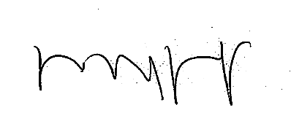

Mrs L Bagshaw
Head of Sixth Form

