Media Studies – Home Learning Pack – 3.2 Summer Term

Dear students and parents,

I hope you are all well.

Continuing at this difficult time, it is still really important that you are studying at home. Next year you will have your GCSEs and all the work that you do now will prepare you for taking those exams.

We understand that accessing schoolwork online or being effectively organised to complete all your different subjects might be difficult. To help we’ve printed this pack. It covers two topics that will be on your GCSE next year. A good amount of work would be to complete 3 lessons a week – but 2 will also be ok.

In this pack you will cover the topics of:
- Magazines
- Radio

Some of the lessons have audio to help, that will guide you through the lesson.
Use your phone to access them on YouTube. However, if that isn’t possible you there is still enough information to complete the work.

Each lesson should take you about 45 minutes to complete.
- Make sure that you take your time.
- Read all the information and watch the videos provided.
- Reread and re-watch what you don’t understand the first time.
- Highlight or underline key phrases or word.
- Look up words that you don’t understand on Google or a dictionary.
- Message your teacher if you need help or don’t understand something.

As you have complete each lesson please upload to SMHW a clear photograph of the pages to your teacher:

Magazines Lesson 1: Magazine Conventions

Please load this lesson video before you start: ????????
If you can’t watch the video you can still complete the tasks.

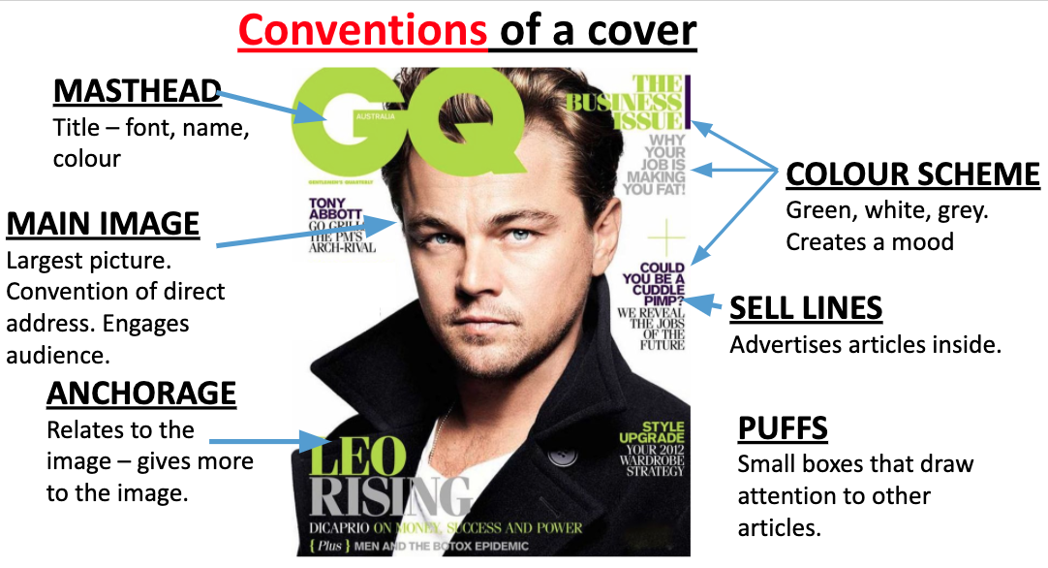
TASK 1: We need to learn the media terminology for what is on the front cover of magazines. These are conventions (what is commonly used).

Now label this magazine front cover with the same conventions.
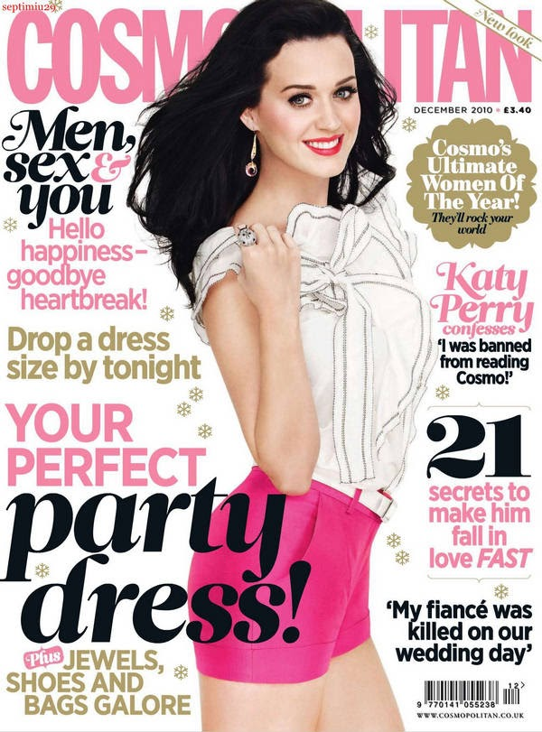

TASK 2: You need to then analyse the conventions for the meaning that they are communicating. Read through the meaning that is created by the conventions on the GQ Magazine.
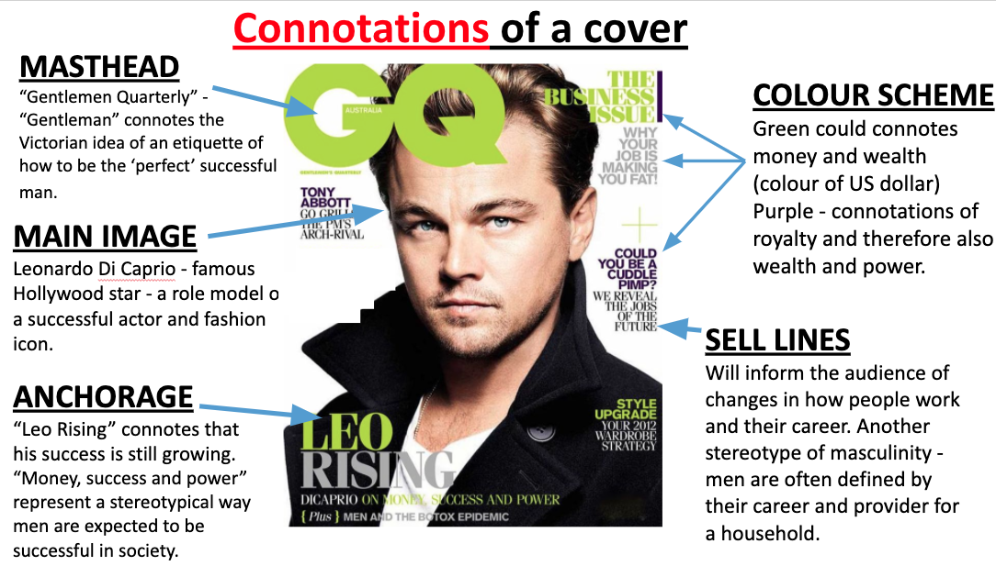

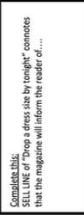
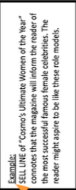
Now analyse the conventions on the front cover of Cosmopolitan. Label 4 other conventions - what are they communicating about Katy Perry, the magazine, the stories that will be in the magazines or what they audience will learn from the magazine?

Magazines Lesson 2: Magazine Conventions

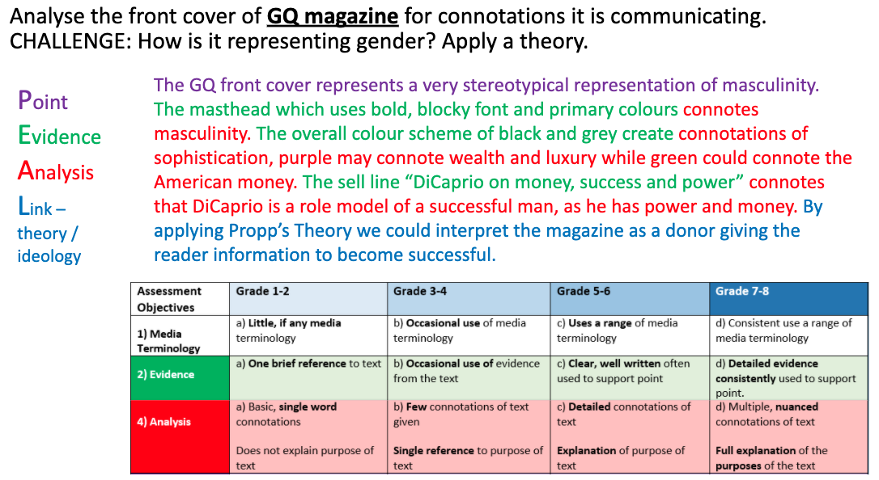
TASK 1: Next try and write two detailed paragraph analyse one or two conventions on the cover of Cosmopolitan magazine. First read the example below analysing the cover of GQ magazine.

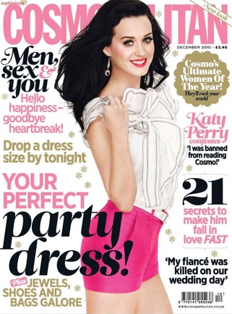
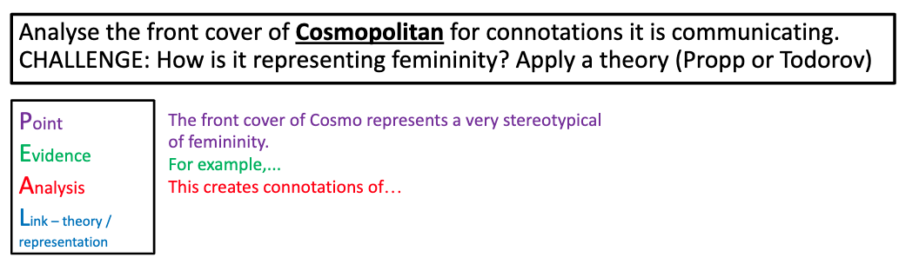
Now write your own two paragraph about COSMOPOLITIAN magazine front cover. Use the sentence starters to help you.

Magazines Lesson 3: Intro to Closer Magazine
Please load this lesson video before you start:
If you can’t watch the video you can still complete the tasks.

TASK 1: Recap from last lesson. Answer the questions below. Afterwards go back to last lesson and check. Correct of fill in any answers.
- What is the MASTHEAD of a magazine?

- What does CLAMPS stand for?

- What is the definition of anchorage?

- What does sell-lines tell the reader?

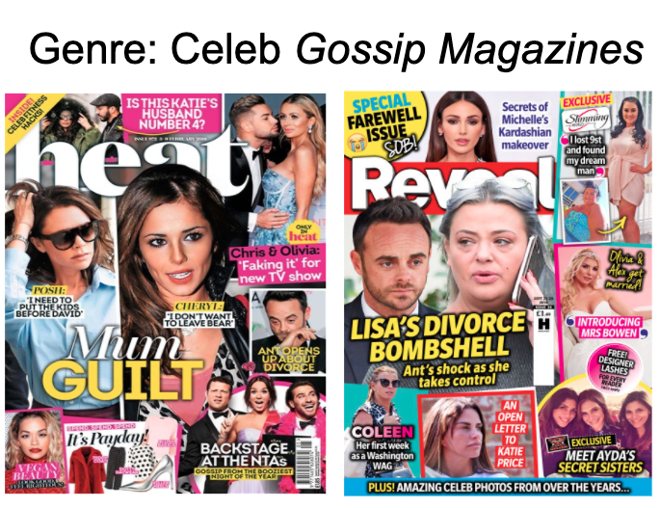
This unit we will be studying the celebrity gossip magazine Closer. Here are some OTHER examples of celebrity gossip magazines.
Task 2: BULLET POINT the content that appear on the cover of GOSSIP MAGAZINES.
- Who are they about?
- What information will the reader find out?
- What things will the reader learn?

Task 3: Label the front cover of Reveal magazine with magazine conventions:
- Masthead
- Anchorage about Beyonce
- 3 Sell Lines
- The Main Image
- A Puff
- Direct Address (when the model is looking at the camera)

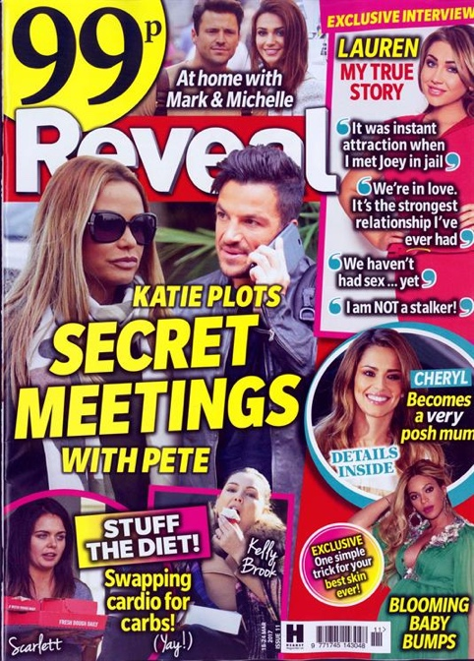

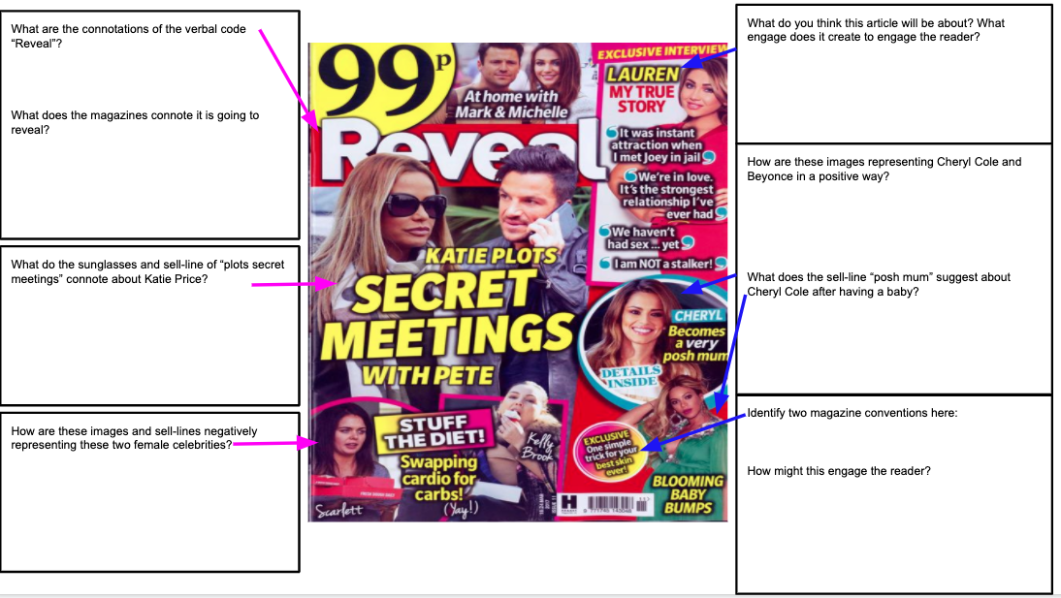
TASK 4: Answer the questions in the boxes in full sentences.

Magazines Lesson 4: Intro to Closer Magazine

Task 1 : You can apply narrative theories to a media text to help make further interpretations of meaning. We will apply Todorov’s Narrative Theory and Propp’s Character Theory to the front cover.
Propp’s character: Hero, Villain, Helper, Donor, Princess, False Hero, Dispatcher
Todorov’s Narrative: Equilibrium, Disruption, Recognition, Climax, Resolution
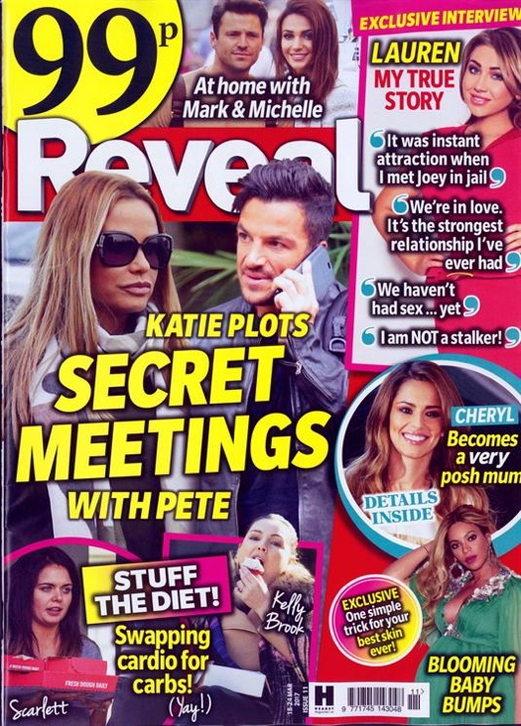

- Using evidence explain why Katie Price might be a villain in Propp’s Character Theory.

- “One simple trick for your best skin ever” - what does this sell-line suggest the character role of the magazine itself is?

- The sell-line “Stuff the Diet” could be disruption in Todorov’s Narrative theory - explain what this problem or disruption are.

- What techniques and conventions have been used to engage the target audience?.

Magazines Lesson 5: Intro to Tatler Magazine
Work through the exercises.

In this lesson we will be looking at a very different magazine called Tatler. This is aimed at upper class and wealthy people.

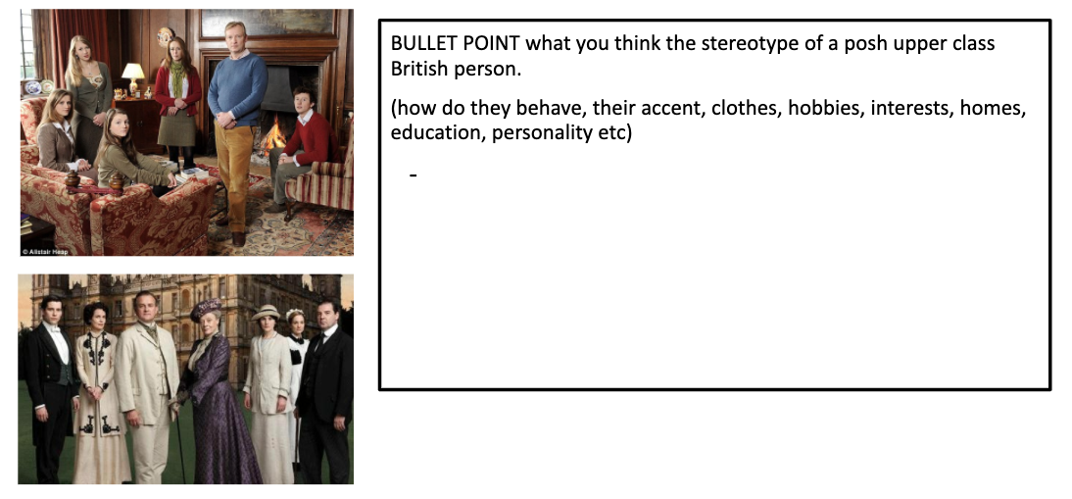
TASK 1:

TASK 2: We need to understand more about the target audience of Tatler magazine. Below is information about the target audience of the magazine. Answer the questions

- What is the average age of a Tatler reader?

- What is the HHI (Household Income) of a Tatler reader (UK average £29,000)?

- Where are the majority of Tatler readers from in the UK?

- Which gender reads the magazine more?

- Is the target audience of Tatler magazine mass or niche audience? Explain why.

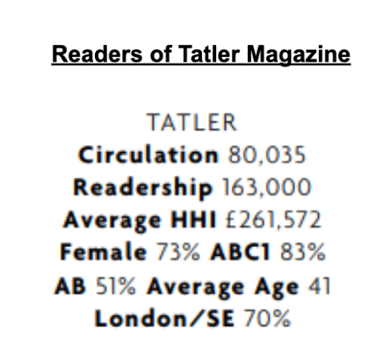

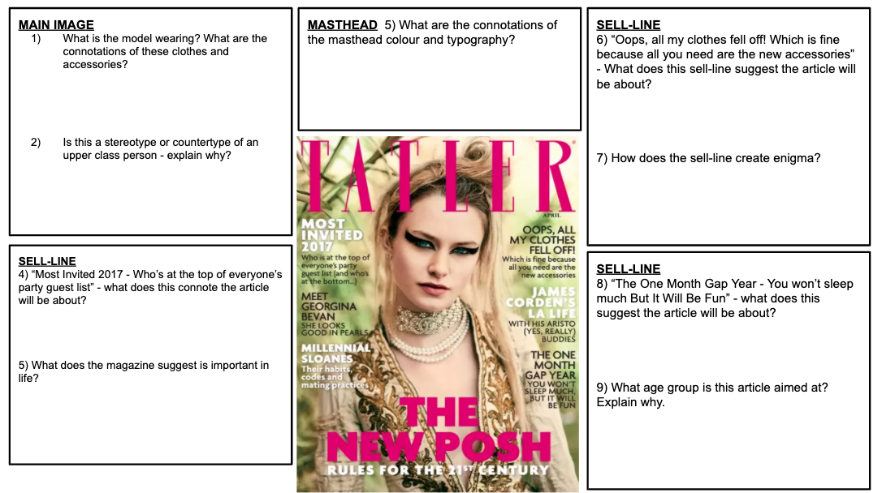
TASK 3:AnalyseTask the front cover of the magazine. Explain the deeper meaning.
Magazines Lesson 6: Representation in Tatler Magazine
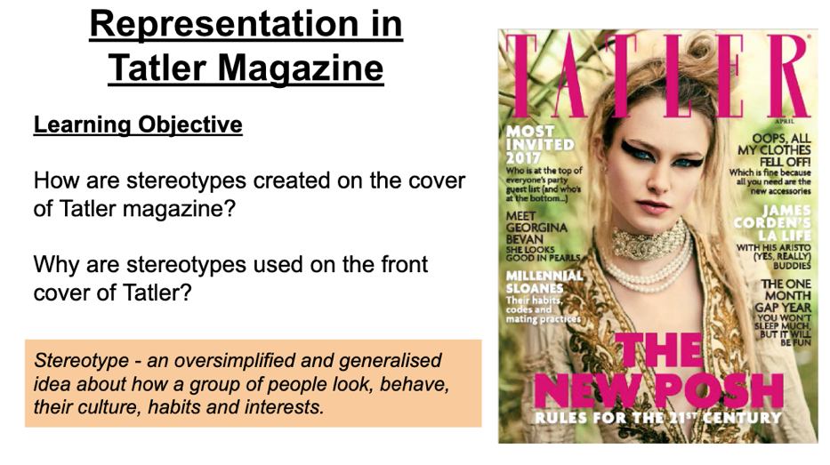
Lets look at the representation of the magazine? Can you remember the concept of representation?

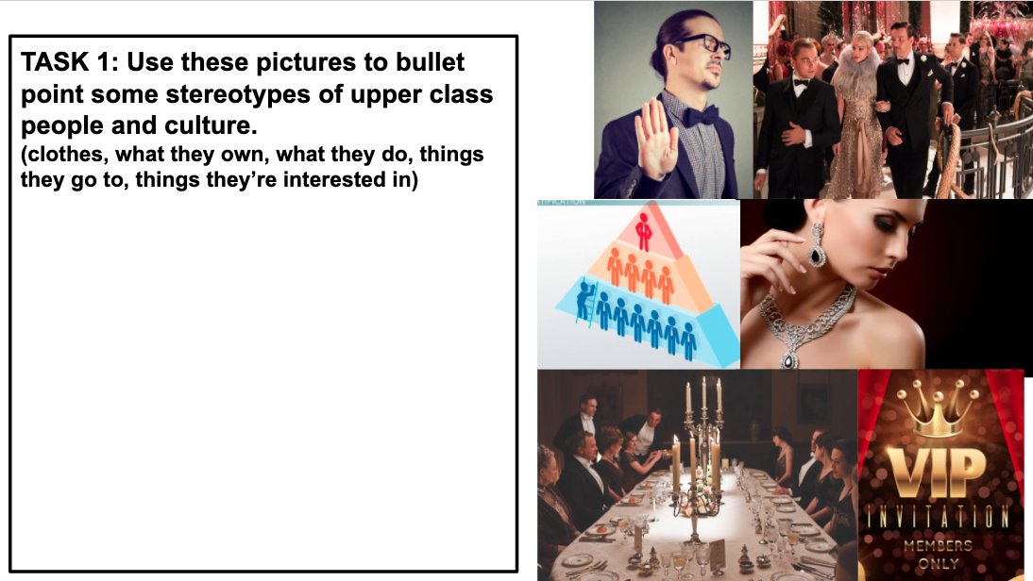
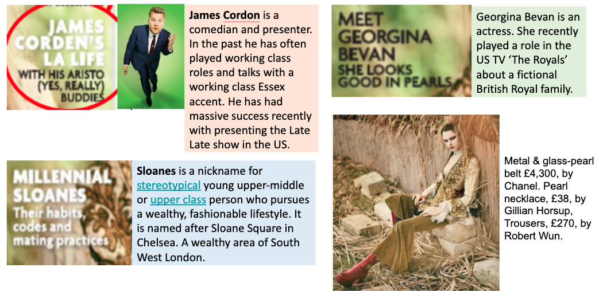
TASK 2: Read through this key information. It will help you understand more about what the sell-lines mean.
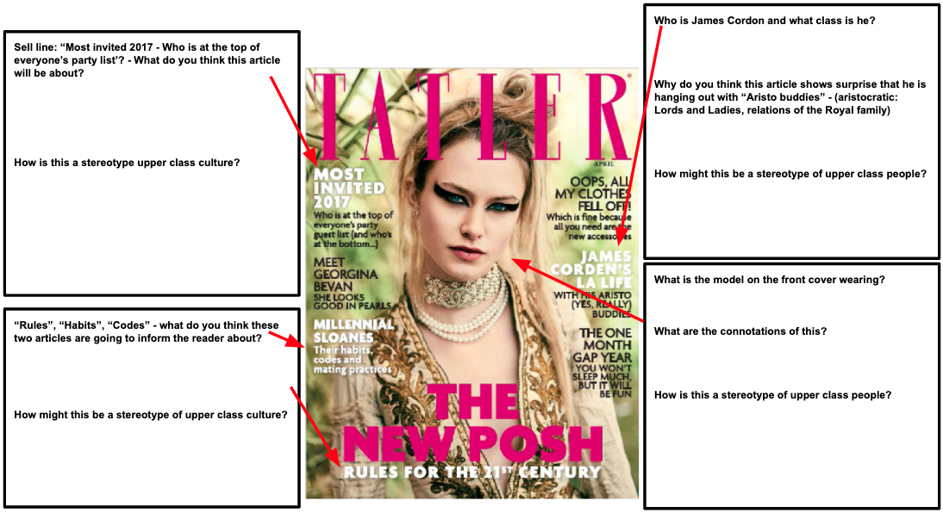
Task 3: Answer the questions in full sentences.
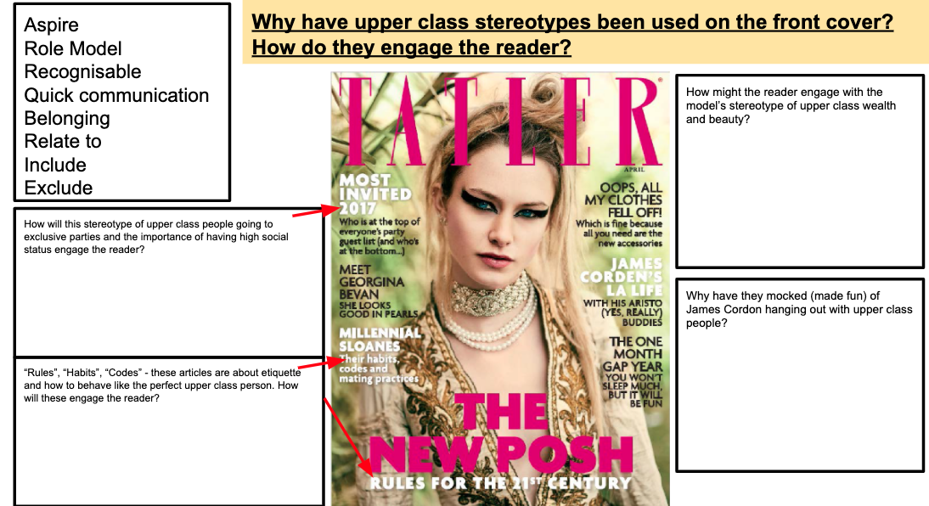
Task 4: Answer the questions in full sentences.
Radio Lesson 7: The creation of BBC Radio 1
This is a new unit! We will be studying the creation of BBC Radio 1 in 1967!
We will be studying why it was created by the BBC, what is its target audience was and how it appealed to them.

In this lesson we will be looking at the historical context of the 1960s to help us understand reasons why the BBC started Radio 1.
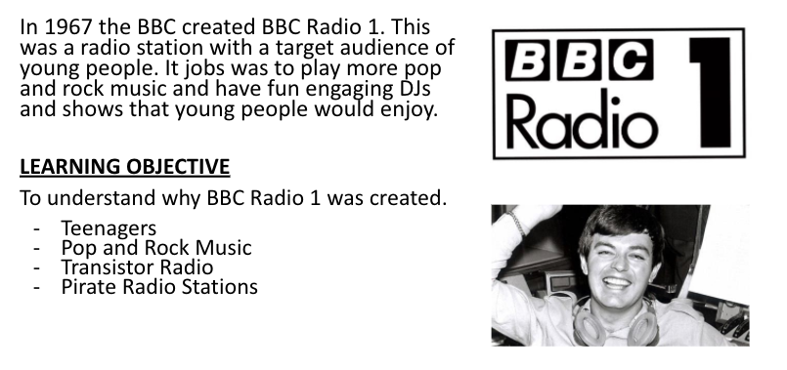

People accessed music very differently in the 1960s. It’s important to understand this compared to now.

TASK 1: Read the information in the table about how people accessed and listened to radio in the 1906s. Complete the column explaining how this had change now.

 | 1960s | 2020
How do people mostly access music? | Music was mostly accessed through radio. Owning music on vinyl and record players was expensive.
What do people listen to music on? | Often a house had only ONE RADIO that would be in the living room.
When can people access music? | Radio only broadcast music AT SPECIFIC TIMES. Often morning until midnight.
How many radio stations are available? What is the variety? | In the 1960s there were only 3 radio station in the UK. They were all ran by the BBC: BBC Radio Home, BBC Radio Light and BBC Third. They mainly broadcast news, educational programs, drama and comedy. No much music was played.
What audiences were targeted to by radio? | BBC radio mainly targeted middle aged audience. Little to no youth music was played.

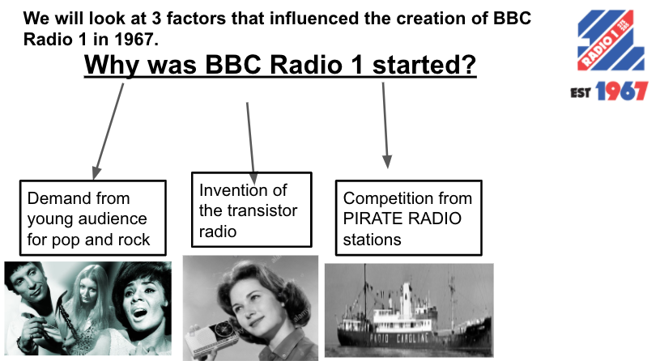

TASK 2: Read the information below and watch this video:
https://www.youtube.com/watch?v=7Y39ciIxWZQ&feature=emb_title
Or search on YouTube: ‘Transistor Radio: The Beginning” (it is the first result)

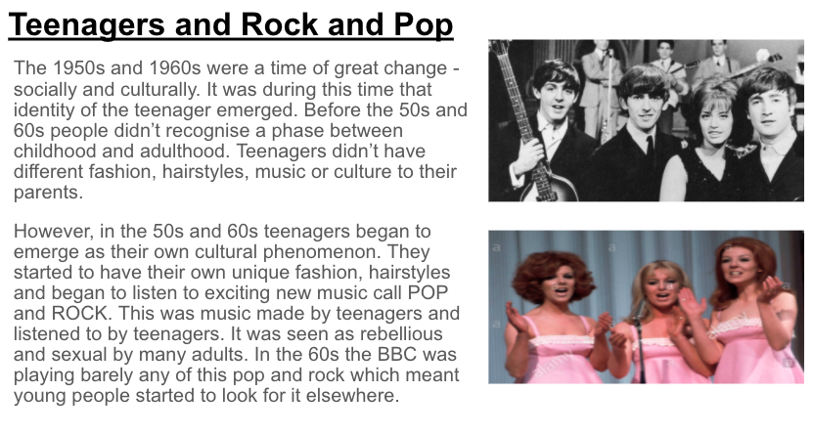
Then answer the questions in full sentences.

Teenagers
- How were things different for young people in the 1950s and 60s compared to the past?
1. How were things different for young people in the 1950s and 60s compare to before that?

2. What was the new music that young people started listening to in 1960s?

3. In the 60s very few young people were listening to BBC radio stations. Why do you think this was?

4. What might have been a reason that the BBC created BBC Radio 1?

5. What were radios like before the transistor radio?

6. What was special about the transistor radio?

7. Why was this such a revolution in media – particularly for teenagers?
Radio Lesson 8: Pirate Radio Stations

TASK 3: Read the information below and watch this video:
https://www.youtube.com/watch?v=RVVXX2UEZEs&feature=emb_title

Or search on YouTube: ‘Offshore Radio in 60’s’ (it is the first result)

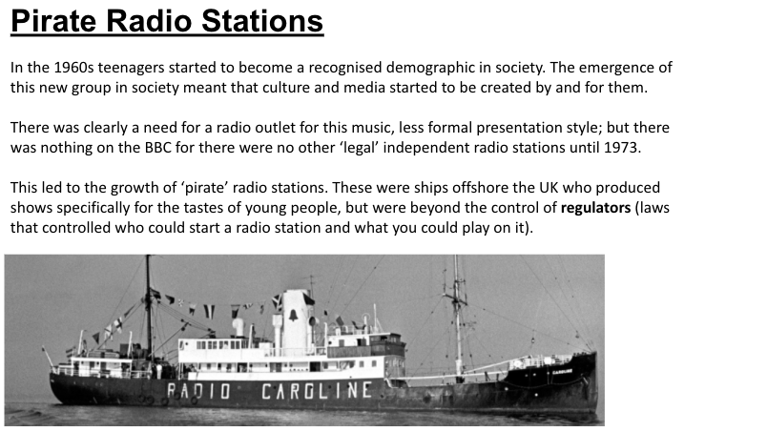

- What was pirate radio?
1. What was pirate radio?

2. Who was making pirate radio?

3. How many different pirate radio stations were there?

4. What music was pirate radio playing that the BBC weren’t playing? How did this make pirate radio stations successful?

5. What eventually happened to the pirate radio stations?

6. What did the DJs from pirate radio do afterwards?
- Who was making pirate radio?

- How many different pirate radio stations were there?

TASK 4: Write 2 paragraphs explaining in your own words explaining why the BBC created Radio 1.
- You must use the keywords in the list.
- Make sure you explain the 3 reasons the BBC started BBC Radio 1.
- Use connectives (for example, because, therefore, however, but, in order to..)
- Your answer must be 150 words.
Teenagers
Target audience
Audience demand
Rock and Pop Music
Transistor Radio
Pirate Radio
Competition

Radio Lesson 9: The BBC and Regulation
In this lesson we will look at the BBC as an institution and how this influenced the creation of Radio 1. We will also look at government regulation of radio – particularly pirate radio – and how this led to the end of pirate radio and the success of Radio 1.
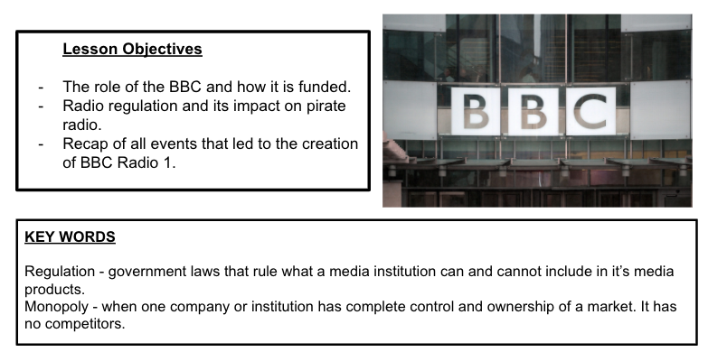

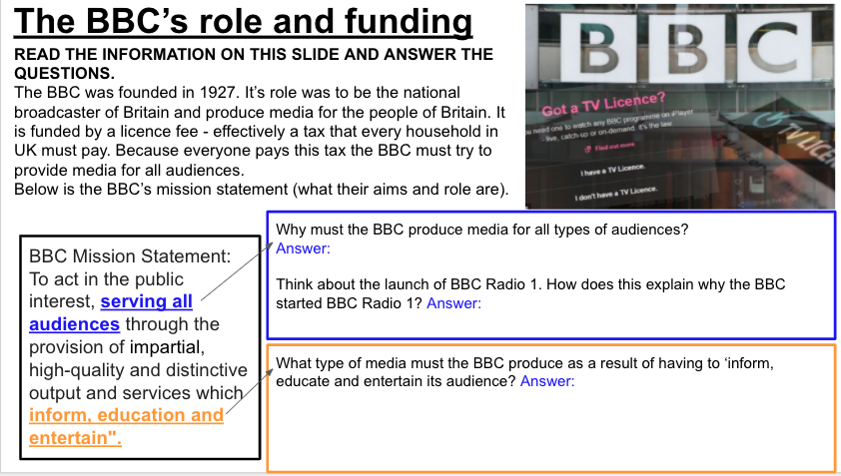
TASK 1: Read the information about the BBC and answer the questions.
Radio Lesson 10: Pirate Regulations

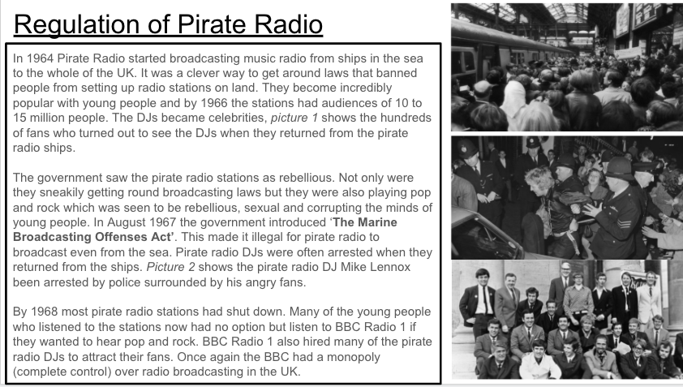

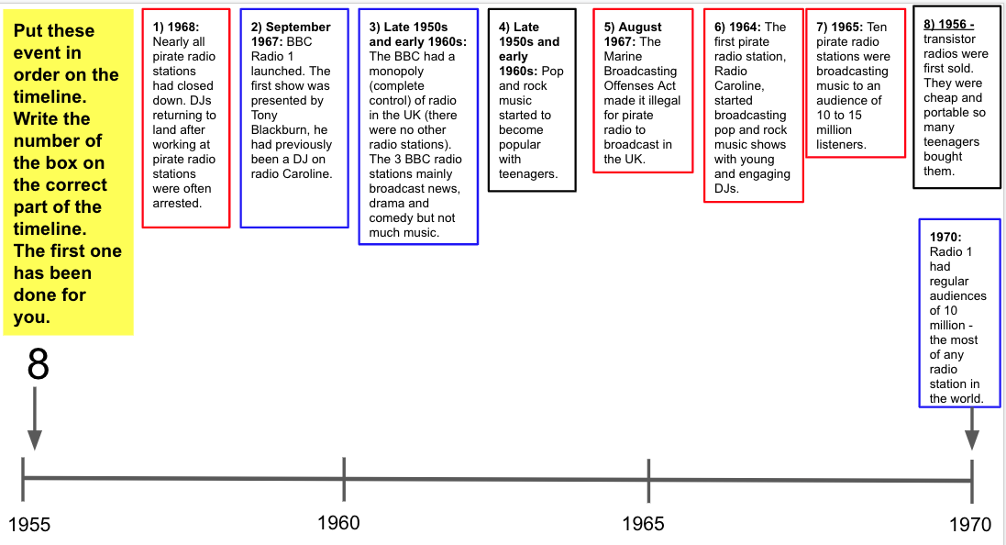
TASK 2:

Radio Lesson 11: Pirate Regulation and Analysis

TASK 3: Write 2 paragraphs answering the question below. Use the sentence starters to help you.

Radio Lesson 12: Compare and Contrast Radio.

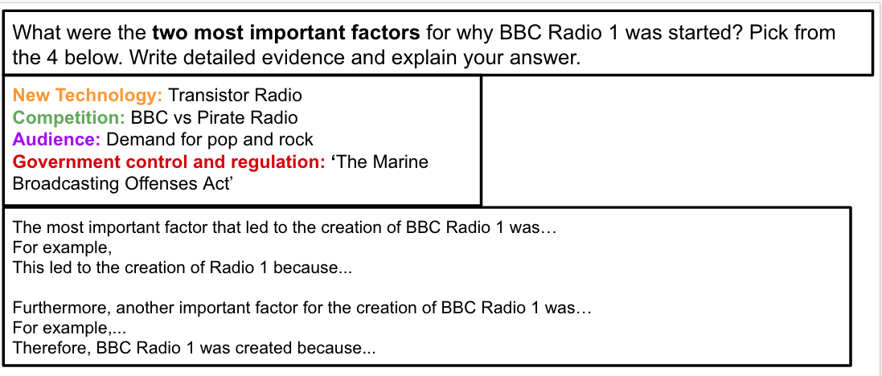

- How were things different for young people in the 1950s and 60s compared to the past?How were things different for young people in the 1950s and 60s compared to the pas

