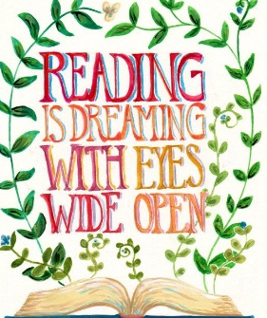
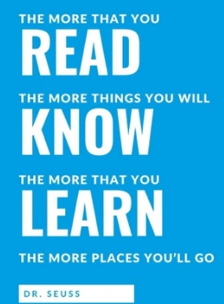
Summer Readathon
Name:
Book and Author | Book Level (Bronze, Silver or Gold) | Date Started | Date Finished | Personal Rating (1 – 10)
Challenge Book!
Challenge Book!
Libraries near you:

Hendon Community Library, 67 Toward Rd, Hendon, Sunderland SR2 8JG
Sunderland City Library, Burdon Road, Sunderland, SR1 1PP
Kayll Road Library, Kayll Road, Sunderland, SR4 7TW

