16th September 2020

Dear Parent/Carer
School Photographs

In accordance with Government guidance and as part of our commitment to creating an environment that minimises the risk of Covid-19 transmission, annual school photographs will be limited to Year 7 pupils only this Academic Year.

One of the reasons for this is that we require images of our new starters for their internal school record.

It is unfortunate that we are not able to photograph all year groups this time but hope to reinstate this next academic year.

Thank you in anticipation of your patience with this matter.

Yours sincerely

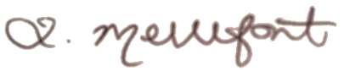

Mrs L Mellefont
Assistant Principal

S:\Letters to Parents\School Phptographs Letter to Parents Years 8-11.docx

