16th September 2020

Dear Parent/Carer
School Photographs

Individual school photographs will take place for all Year 7 pupils on Friday 25th September. Please ensure your child is wearing full school uniform and maintains their excellent appearance in anticipation of this.

Details of how to order and purchase your child’s portrait should you wish to, will follow in due course.

Yours sincerely

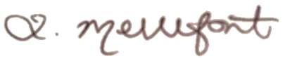

Mrs L Mellefont
Assistant Principal

S:\Letters to Parents\School Phptographs Letter to Parents Years 7.docx

