

**Welcome back!**

We hope your child has had a safe and enjoyable summer, and they are now settled and excited for the year ahead in History at Southmoor Academy. This year we have a department newsletter to provide parents and carers with information on the current topics being studied, extracurricular activities and some guidance for parents and carers for all our historians.

History Newsletter: Term 1

Year 7 History

**2.The Industrial Revolution**

1. Knowledge Organisers

2. Online quizzes

*1. The Ruby in the Smoke,. Philip Pullman (Book)*

2. Watch ‘The Mill’ television series

*1. Barmy British Empire, Terry Deary (Book)*

2. Watch ‘Victoria’s empire’ – BBC series

**Optional Extras**

1. Knowledge Organisers

2. Online quizzes

**Homework**

1. How did town life change in Britain?

2. Why did so many people want to move to industrial towns?

3.What happened at Peterloo to be a massacre?

4. How successful was the protest movement in the 19th century?

1. Which countries established empires?

2. How were natives affected?

3. What positives did an empire bring to Britain?

4. Should Britain be proud or ashamed of its empire?

**Questions you could ask at home**

The unit focuses in the impact the Industrial Revolution had on political, social and economic ways of life in Britain. Students also study the popular protest movement in the 19th century and calls for universal suffrage.

We investigate the reasons why European countries established empires and the impact this had on people’s lives who were controlled. We also study the legacy of the empire and Britain’s reputation.

**1.The impact of the British Empire**

**What are we learning?**

Year 8 History

1. Knowledge Organisers

2. Online quizzes

**Homework**

Homework is a core part of KS3 History and serves to support the learning we do in class, enrich the student experience and develop learning skills. All homework is set using Show My Homework. There are 3 types of homework set in History.

**1.Knowledge Organisers**

These provide the basic knowledge for each topic. This may include a timeline, key words, key concepts and summarises. These are tested in regular quizzes.

**2.’Meanwhile, elsewhere’**

What we learn in the classroom only offers a small glimpse of the past. To widen students understanding of the past, one page research sheets will accompany each topic. These will provide a glimpse in to what else was going on around the world at the same time as the topic we are studying. These are handed out and put on SMHW and students independently research them and hand these in to their teacher.

**3. Revision**

Preparing for History assessment is an essential part of each topic as each assessment allows teachers and students to see their progress in History. It is crucial this revision is done so that our students can showcase what they know.

**Extracurricular**

As a department we hope to be launching a History cinema club, showing films that match our current topics at KS3.

Additionally, there may be possibilities of educational visits taking place during the course of the academic year. More information will follow.

**Contacting the department**

As a department we can be contacted via email using [info@southmoormat.co.uk](mailto:info@southmoormat.co.uk) or teachers individually using Show My Homework.

Mr Ireland

**Curriculum Leader of History**

1. Knowledge Organisers

2. Online quizzes

*1.Riddle of the Ruins, Janina Ramirez (Book)*

2.Watch ‘Bloody Britain’ – Vikings episode

*1.Max and the Midnights, Lincoln Pierce (Book)*

2.Watch ‘A Knight’s Tale’

**Optional Extras**

**Homework**

1.What weapons did the Vikings use to fight?

2.How did the Vikings take control of the North of England?

3.What happened at Lindisfarne in 793AD?

4.Were the Vikings all bad for the English?

1.How did William become king?

2.What methods did the Normans use to take control of England?

3.How did the Normans change society?

4. Did the Normans only bring trouble to England?

The impact of the Norman Conquest on England from 1066 onwards. We focus on how the invasion affected the role of the church, people’s lives and the power of the monarchy

**Questions you could ask at home**

**What are we learning?**

**1.Viking settlements**

**2.Norman invasion&conquest**

We investigate the results of the Viking invasion on England. We study how they became the most feared warriors in Europe and the results it has left on the North East of England.

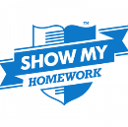





What to look forward to in Term 2… In **Year 7** we will be studying famous medieval events such as the Magna Carta, Black Death and Peasants Revolt! In **Year 8** we will be moving into the early 20th century in which we will study the Suffragette Movement and the causes of the First World War!

Students have already studied all units for their summer exams. It is now our job to make sure that key facts are embedded into their long-term memory. We will be mixing these topics up so to strengthen your child’s recall qualities.

**Y11 Corner**

**All units at GCSE History**

**What are we learning?**

Year 11: GCSE History

*1. My Revision Notes: AQA GCSE History (Revision Guide)*

2. <https://www.johndclare.net/>

3. <https://www.bbc.co.uk/bitesize/guides/zsh9bk7/revision/5>

**Optional Extras**

1. Homework exam booklets

2. Online quizzes

1. Homework exam booklets

2. Online quizzes

**Homework**

1. What was the aim of the League of Nations?

2. What were the strengths of it?

3. What were the weaknesses of it?

4. Why did the Manchurian and Abyssinian Crises lead to the League failing?

1. Which countries were in charge at the Versailles settlement?

2. How were Germany affected by the Versailles settlement?

3.Who else were ‘losers’ at Versailles?

4. Who was most pleased at Versailles?

**Questions you could ask at home**

In this section students will study the establishment of the League of Nations and the successes it had during the 1920s. Following this students will investigate the demise of the League during the 1930s and the rise of Hitler.

Students will start Section B of Paper 1. This focuses on Conflict & Tension between 1919-39. We will investigate the impact the Treaty of Versailles had on the countries affected by the First World War.

**2. Conflict & Tension, The League of Nations**

**1.Conflict & Tension, Peacemaking**

**What are we learning?**

Year 10: GSCE History

Year 9 History

**What are we learning?**

**1.Origins of the Cold War**

**2.Development of the Cold War**

We investigate the world after WWII and the emergence of the 2 superpowers, USA and USSR. Students will study the different political and social beliefs they had and how this affected events after 1945.

Students will be studying how the USA and USSR attempted to maximise their influence around the world and how this led to significant conflict with other countries.

**Questions you could ask at home**

1. What did the ‘Cold War’ mean?

2. What are the differences between Capitalism and Communism?

3. What was the Berlin crisis?

4. How did the USSR increase their control in Eastern Europe?

1. Why did the Cuban Missile Crisis nearly lead to nuclear war?

2. Who else could have assassinated JFK?

3. Why did the USA get involved in Vietnam?

4. Did the USA win the war in Vietnam?

**Homework**

1. Knowledge Organisers

2. Online quizzes

1. Knowledge Organisers

2. Online quizzes

**Optional Extras**

*1. A Night Divided, Jennifer Nielson (Book)*

2. Watch ‘Cold War’ TV series

*1. The Red Umbrella, Christina Gonzalez (Book)*

2. Watch ‘Thirteen Days’

**How can you help your child’s progress?**

Retrieval pacts have been created for both students and parents/carers. Your copy has answers attached so you can test your child’s knowledge. You will receive these pacts shortly! Flashcards and testing your child’s knowledge are a popular way to revise. These are available to buy at Wilkos’ for approximately £1 for 100 cards

**Homework**

1. Homework exam booklets

2. Online quizzes

3. Retrieval Pacts

**1.Mock exams**

In this term Year 11 students will be sitting their first mock exams. This will be based on content they have studied at GCSE History. Although these exams are mocks students need to view these as a really important opportunity to test their knowledge and becoming accustomed to the environment of exams. Students will sit 3x History papers for their mocks; USA, 1920-1973 and Conflict & Tension, 1919-1939 and Health and the People, 1000-Modern Day

**Extracurricular**

As a department we will be launching our ’remote’ revision sessions. There will be weekly revision sessions on Google Classroom. Students will be expected to watch and complete key tasks and use this an opportunity to enhance their knowledge and skills

**Revision**

We appreciate that revision is tough. That is why we are determined that showing students how to effectively revise will help with all their subjects. Parents/Carers are crucial to their child’s successes, which is why we have highlighted different strategies below to help.

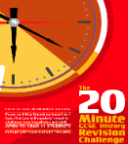



What to look forward to in Term 2…

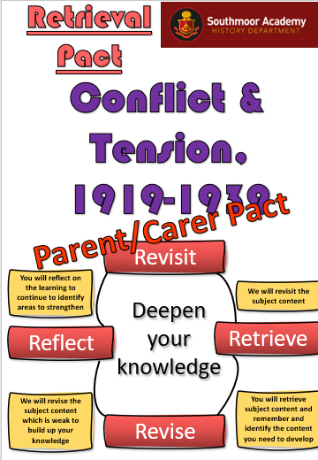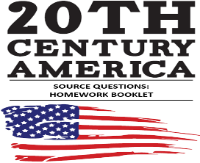



In **Year 9** we will be studying the USA during the 1920s and 1930s and how it went from the ‘Roaring 20s’ to the ‘Great Depression’

In **GCSE** **Year 10** we will be investigating Hitler’s aims in foreign policy and the events that led to World War Two.

In **GCSE** **Year 11** we will be continuing to support and challenge students with their revision and retrieval skills in the lead up to the final round of mocks and their drive towards the summer exams.

‘20s’ to the ‘Great Depression’

