SCHOOL EQUIPMENT

We are pleased to offer all students at Southmoor a free branded pencil case on their first day at school next year. The pencil case contains the essential equipment you will need every day at school. Pupils must bring at least this equipment with them every day they are in school and keep it in good condition.

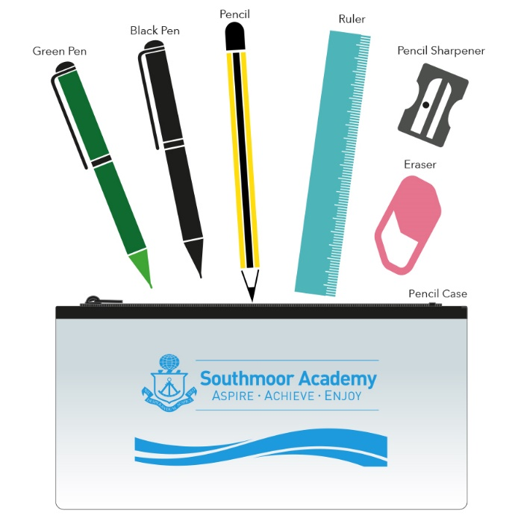

Pupils must also bring a suitable bag to school every day, to carry their equipment, planner & books.

Please turn over…
The required equipment for every day at Southmoor is:
- A Black Pen
- A Green Pen
- A Pencil
- A Ruler (15cm)
- A Pencil Sharpener
- An Eraser
- A Pencil Case to hold all of the above
- The pupil planner provided to all students at the start of each school year
- A suitable bag to hold the above plus books and other equipment
- A re-usable water bottle. Sports-type or metal. Filtered water dispensers are positioned around the Academy, where pupils can replenish their bottles at break and lunch time. Please note that other drinks such as energy, soft and carbonated drinks are prohibited and must not be brought in to school. Pupils will have the option to purchase a healthy juice drink or a hot drink at school, alongside free access to filtered water.
Please note: All of the above equipment can be replenished at the in-school shop open every day at break time next to the House Leader’s Office.

Pupils may also consider bringing:
- Colouring pencils
- A calculator
- An inexpensive wrist watch
Please note: Though this equipment can prove useful, it is not essential and will sometimes be supplied by the school when necessary.

Pupils should not bring:
- Headphones
- Mobile Phones (Although we accept that a mobile phone is sometimes necessary for parent-pupil contact, it should be turned off during the school day and remain out of site. It should never be used at any point during the school day or on school premises. Phones will be confiscated by staff should students be seen using their phone or other connected device. Please also note that the Academy will take no responsibility for any such items brought into school that may become damaged, lost or stolen)
- ‘Tippex’ or eraser fluid
- Scissors or any other sharp object
- Marker pens

