**BLACK LIVES MATTER**

Following the death of George Floyd in the USA and the subsequent protests worldwide, I am sure many students, staff and parents are feeling concerned and anxious about the events.

How best to approach these matters with students and the wider community is a difficult question. However, it would seem the most helpful way is through the following -

**EDUCATE**

“EDUCATION IS THE MOST POWERFUL WEAPON WE CAN USE TO CHANGE THE WORLD” Nelson Mandela

Educating ourselves is an important tool. Here is a list of suggestions from the teachers of The John Roan School of things you can read, watch, or listen to in order to better educate yourself on the historical context surrounding the current events.

**Why are people in the UK upset about this?**

* <https://www.bbc.co.uk/news/newsbeat-52877803>
* <https://www.theguardian.com/uk-news/2016/aug/06/black-lives-matter-uk-found-vital-social-justice>
* <https://www.benjerry.com/home/whats-new/2016/systemic-racism-is-real>

ACTION – What effective action can we take to safely support the Black Lives Matter protests?

AWARENESS – How best can we use social media and the news to stay informed whilst protecting our mental health and critically evaluating sources of information?

EDUCATE – What can we read, watch, and listen to in order to educate ourselves on the historical context surrounding these events?

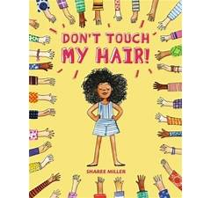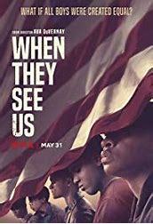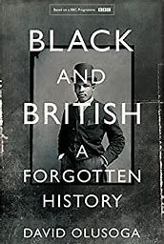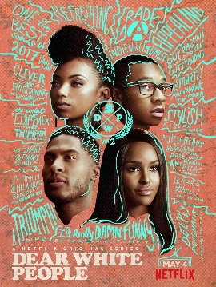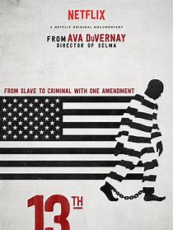

* 13th (15)
* Becoming
* Teach us all
* I am not your Negro (12A)
* The Last Dance
* When they see us (15)

**Television**

* Dear White People (15)
* Noughts + Crosses
* When they see us

**Documentaries**

**Fiction books**

**KS3:**

* The Hate U Give by Angie Thomas
* On the Come Up by Angie Thomas
* Noughts & Crosses by Malorie Blackman
* Love, Hate & Other Filters by Samira Ahmed
* A Change Is Gonna Come A series of short stories by various BAME authors

**KS4/ KS5:**

* Girl, woman, other by Bernadine Evaristo
* The Poet X by Elizabeth Acevedo
* Dear Martin by Nic Stone
* That Asian Kid by Savita Kalhan
* Run, Riot by Nikesh Shukla
* Terror Kid by Benjamin Zephaniah

**KS3:**

* Don’t touch my hair by Sharee Miller

**KS4/ KS5:**

* Born a Crime by Trevor Noah
* Natives by Akala
* Why I’m no longer talking to white people about race by Reni Eddo Lodge
* Don’t touch my hair by Emma Dabiri
* Brit-ish: On Race, Identity and Belonging by Afua Hirsch
* How to be an anti-racist by Ibram Kendi
* Black and British, A forgotten history' by David Olusoga
* The Civil Rights Movement (a Step Into History) by Olugbemisola Rhuday-Perkovich

**Non-fiction books**

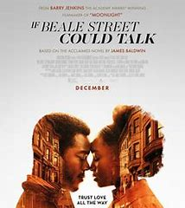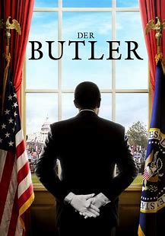

**Articles**

* An article by Deray Mckesson on what you can do as an ally-

<https://ideas.ted.com/how-you-can-be-an-ally-in-the-fight-for-racial-justice/?utm_source=instagram_stories&utm_medium=referral&utm_campaign=social&utm_term=social-justice>

* An article relating to being mixed race and British-

<https://amp.theguardian.com/uk-news/2019/may/12/what-does-archie-tell-us-about-mixed-race-britain>

* Britain's black power movement is at risk of being forgotten, say historians- <https://www.theguardian.com/world/2013/dec/27/britain-black-power-movement-risk-forgotten-historians>
* Learn more about the Windrush generation- <https://www.bbc.co.uk/news/uk-43782241>
* How the forgotten organisers of the Bristol Bus Boycott changed the course of workers’ rights: <https://gal-dem.com/how-the-forgotten-organisers-of-the-bristol-bus-boycott-changed-the-course-of-workers-rights/>

**Lectures**

There are lots of ‘Ted talks’ you can access on YouTube around race, racism and immigration.

* Chimamanda Ngozi Adichie's Ted talk on "The Danger of a Single Story"
* Luvvie Amati- Get comfortable with being uncomfortable
* Verna Myers- confronting racial bias
* Rabbit Proof Fence (PG)
* The Butler (12A)
* Selma (PG 13)
* Malcolm X (PG 13)
* The Hate U Give (PG 13)
* Get out (15)
* 12 years a slave (15)
* Fruitvale Station (15)
* Mudbound (15)
* The last black man in San Francisco (15)
* Just Mercy (12A)
* Toni Morrison: The pieces I am (12A)
* BlacKkKlansman (15)
* If Beale street could talk (15)
* Green Book (12A)
* The Best of Enemies (12)

**Films**

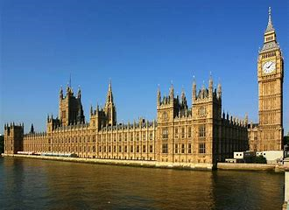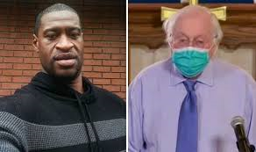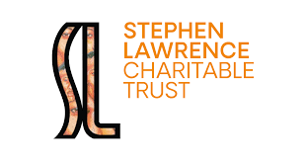

**ACTION**

“BE THE CHANGE YOU WISH TO SEE IN THE WORLD” Mahatma Gandhi

Often, you can feel quite helpless in situations that feel big and important. This is not a complete list of all the things you can do to help racism in the UK, just a guide to some practical things that are within your power.

**Write to your MP**

Members of Parliament (MPs) in the UK are elected to represent the people of the area they work in. You can go to <https://www.theyworkforyou.com/mps/> to see how your MPs vote on different issues. If they have not spoken out against the murder of George Floyd, you could send them an email asking them why. You can find their email addresses at: <https://members.parliament.uk/constituencies>

**Start a conversation**

* Talk to others (your friends, family, teachers) about things that make you angry, upset, or overwhelmed.
* Stay up to date with what is happening in the news and politics. Talk to your friends, family, and teachers about it.
* Ask questions about things you are unsure about – nobody is an expert and it is OK to be confused.

A valuable way to have your voice heard is to sign a petition. For example, you could sign -

Justice for George Floyd Petition (<https://www.change.org/p/mayor-jacob-frey-justice-for-george-floyd?source_location=search_index&algorithm=promoted&original_footer_petition_id=&grid_position=6&pt=AVBldGl0aW9uAAoFVgEAAAAAXtE88uaPXFo5YTFmMWVhOA%3D%3D>)

Is there something that you feel particularly passionate about? You can also start your own petition at <https://www.change.org/> In the UK, any petition that gets over 10,000 signatures will get a response from the government and any with over 100,000 signatures will be debated in Parliament.

**Sign petitions**

**AWARENESS**

“I HAVE A DREAM THAT MY FOUR LITTLE CHILDREN WILL ONE DAY LIVE IN A NATION WHERE THEY WILL NOT BE JUDGED BY THE COLOR OF THEIR SKIN, BUT BY THE CONTENT OF THEIR CHARACTER.” Martin Luther King Jr

The endless news cycle and social media can sometimes feel overwhelming, especially in the middle of a global pandemic. It is important that you think about your own mental health in times like this and make sure you are looking after yourself.

It is okay to take a break from social media if you find it is affecting your mood. It is great to be informed and seek out as much information as possible about what is happening, but you can feel overloaded with it sometimes and it can be disheartening.

It is also important when using social media and news outlets to think critically about the sources you are reading or sharing. Ask yourself: why has this author written this? Can this source be verified? What is the agenda of the organisation sharing this source?

**Support organisations/ charities that fight racial injustice**

Donating money is not always easy, or an option for everyone. Lots of organisations/ charities want your support in other ways. This can include sharing a hashtag online or continuing the conversation with people who might not know as much as you. Some organisations you can support are:

* More things you can do: <https://blacklivesmatters.carrd.co/#resources>
* Stop Hate UK (<https://www.stophateuk.org>) [National charity]
* Football Unites, Racism Divides (<https://furd.org/>) [Sheffield based charity which uses football and community to fight racism]
* BTEG (<https://www.bteg.co.uk/>) [National charity aiming to end racial inequality through education and employment]
* Stephen Lawrence Trust (<https://www.stephenlawrence.org.uk/>) [National charity which aims to get rid of institutional barriers in front of young people]
* The Reach Out Project (<https://www.reachoutproject.co.uk/>) [London based charity opening up new opportunities for young BAME people]
* Operation Black Vote (<https://www.obv.org.uk/>) [National charity which aims to increase the number of BME people who vote in the UK]
* Colour of Change <https://colorofchange.org/>

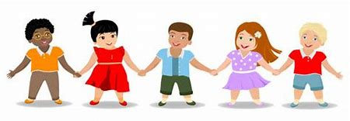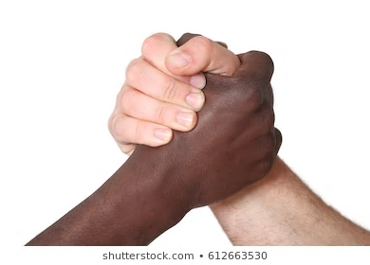

**How can I best support my friends as a non-black person?**

* When it comes to talking to black friends, the priority should be asking if they are okay and then offering to talk if they need it and showing support.
* Remember it is okay if they do not want to, just let them know you are there if they do and that you support them.
* Listen, and do not try to compare someone else's experiences to your own.
* Do not rely on your black friends to explain racism to you. It is not their job, and this may be upsetting for them. Educate yourself.

The important thing to remember is that talking about race is not racist. It is OK – and important. This is how we alter the conversation and make change happen.

**How can I challenge racism when I see it?**

If you see someone is treating someone differently because of their race think about how you can help (the same goes for if someone is treated badly because of their religion, sexuality, gender, or a disability). This could be by:

* Having a calm conversation with the person who has been racist to explain to them why it is wrong and hurtful to treat people differently based on who they are**.**
* Recording any incidents of racism, you see on your phone so you have evidence and can report them.
* Supporting the person who has been treated badly, comfort them, make sure they are okay and that they know they are not alone
* Making an official complaint. This is most effective if you see this happen in a business, or someone in a position of authority like a teacher, police officer or an MP.