Name:

Year 9 German



Autumn Term 1
Workbook

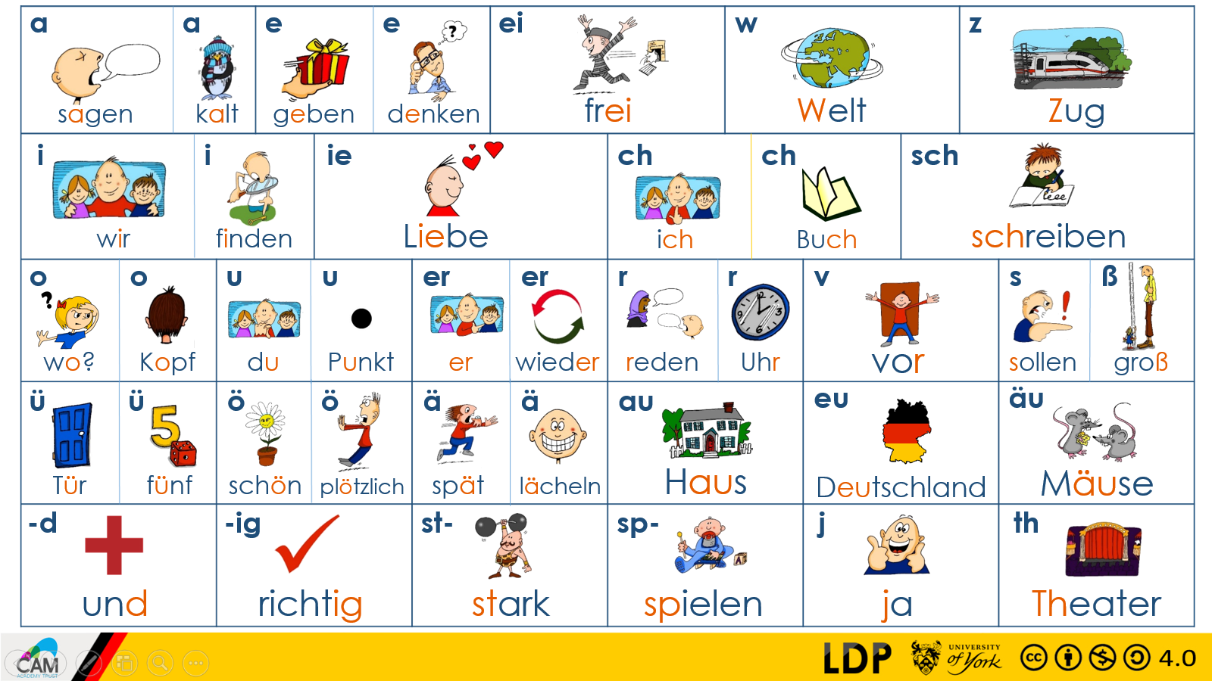

Top tips for success in German:

- Learn vocabulary on a regular basis – little and often is usually best
- Think about how sentences string together with the grammar rules that you learn in class
- Practice your phonics regularly as this will be tested in exams too
- Make sure you find opportunities to listen to German (podcasts, films, YouTube videos, music)

- Complete this booklet (with your teacher’s instruction) to the best of your ability and don’t skip any questions!

- You may need to refresh your memory and look back at previous pages to find the vocabulary you need.

- (WO) means that you need to consider the word order in your sentences

Im Fernsehen
sehen to see
ich sehe I watch
 | Word | English meaning
1 | ,weil
2 | es
3 | sind
4 | lustig
5 | ich
6 | sehe
7 | doof
8 | ist
9 | Krimis
10 | ziemlich
wir sehen we watch
gern like (WO)
nicht gern don’t like (WO)
ziemlich gern quite like (WO)
sehr gern really like (WO)

Krimis crime shows
Sendungen shows
die Nachrichten the news
Seifenopern soap operas
Zeichentrickfilme cartoons

,weil because (WO)
es it
ist is
sie they
sind are
und and

unterhaltsam entertaining
lustig funny
interessant interesting
langweilig boring
blöd/doof stupid/silly

 | Sentences: Translate
1 | I watch crime shows. -
2 | It is funny. -
3 | They are boring. -
4 | We watch the news. -
5 | I like watching the news. (WO) -
6 | Cartoons are stupid. -
7 | ..because it is funny. (WO) -
8 | We quite like watching crime shows. (WO).
Im Fernsehen 2

Ich sehe gern I like watching
Ich sehe nicht gern I don’t like watching

Sportsendungen sport shows
Filme Films
Dokumentationen documentaries
die Nachrichten the news
 | Word | English meaning
1 | Ich finde
2 | sind
3 | kindisch
4 | komisch
5 | Filme
6 | ist
7 | furchtbar
8 | warum?
9 | lehrreich
10 | es

Ich finde… I find…
Wir finden… We find…
Ich denke I think
,dass (WO) that
Warum? Why?
es it
ist is
sie they/them
sind are

spannend exciting
kindisch childish
unterhaltsam entertaining
furchtbar awful
lehrreich educational
beliebt popular
komisch weird

mein/meine My
Lieblingssendung(en) favourite show(s)

 | Sentences: Translate
1 | I think that it is great, (WO) -
2 | They are exciting. -
3 | We find them boring. -
4 | Why is it childish? (WO)
5 | Films are entertaining. -
6 | The news is educational and awful. -
Filme
zu too
gruselig creepy/scary
interessant interesting
dumm dumb
realistisch realistic
 | Word | English meaning
1 | ziemlich
2 | zu
3 | gruselig
4 | kindisch
5 | Komödien
6 | realistisch
7 | witzig
8 | bietet
9 | wirklich
10 | es
gewalttätig violent
spitze great
kindisch childish
international international
witzig funny

nicht not
ziemlich quite
sehr very
wirklich really
echt really

Film(e) film(s)
Liebesfilme romantic films
Komödien comedies
Abenteuerfilme adventure films
Information information

bieten offer
es it
bietet offers

 | Sentences: Translate
1 | Comedies are funny. -
2 | It is quite childish. -
3 | Films offer information. -
4 | Films are violent. -
5 | Romantic films are quite dumb. -
6 | It offers information.
7 | I find them great. -
8 | It is very popular. -
Filmkritik
Was? What?
Warum? Why?
ist is
dein your
 | Word | English meaning
1 | dein
2 | was?
3 | die Musik
4 | die Geschichte
5 | witzig
6 | beliebt
7 | Lieblingsfilm
8 | er spielt
9 | kindisch
10 | ich spiele
Lieblingsfilm favourite film
spielen to play/playing
ich spiele I play
er spielt he plays

der Schauspieler the actor
die Schauspielerin the actress
die Charaktere the characters
die Musik the music
die Geschichte the story
die Spezialeffekte the special effects
das Haupttheme the main theme

 | Sentences: Translate
1 | The characters are funny. -
2 | The music is boring. -
3 | The special effects are great. -
4 | Your favourite film is boring. -
5 | I like watching comedies, -
6 | The actress is entertaining. -
7 | Why is it very exciting? -
8 | What is your favourite film? -

Past tense with haben
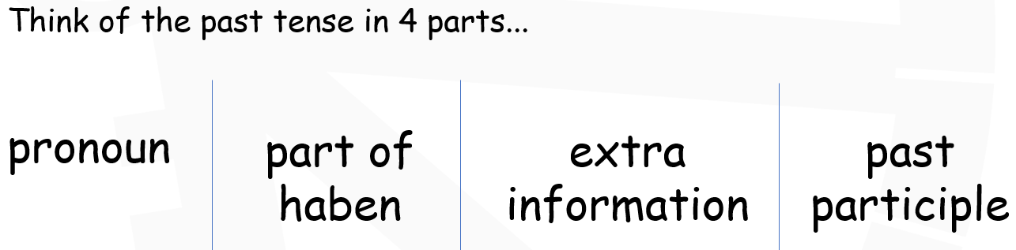
gespielt played
gegessen ate
getrunken drank
 | Word | English meaning
1 | gegessen
2 | gespielt
3 | du hast
4 | er hat
5 | ich habe
6 | gewohnt
7 | getanzt
8 | gekauft
9 | wir haben
10 | gesehen
gewohnt lived
gesehen watched/saw
gekauft bought
gehört listened to
gemacht did/made
getanzt danced
gelesen read

ich habe I have
du hast You have
er hat He has
sie hat She has
wir haben We have
ihr habt You (plural) have
sie/Sie haben They/you polite have

e.g., We ate a pizza = We haben eine Pizza gegessen. (WO)

 | Sentences: Translate
1 | We watched comedies. (WO) -
2 | I ate a pizza. (WO) -
3 | He listened to the music. (WO) -
4 | She bought films. (WO) -
5 | They lived in Sunderland. (WO) -
6 | I watched the news. (WO) -
7 | He watched soap operas. (WO) -

Was hast du gesehen?

If you put it here, you must swap your next two two words!!

A time phrases can go here!

vorgestern the day before yesterday
gestern yesterday
letztes Jahr last year
letzten Monat last month
letzte Woche last week
gestern Abend last night
 | Word | English meaning
1 | gestern
2 | gegessen
3 | gesehen
4 | letzte Woche
5 | ich habe
6 | wir haben
7 | du hast
8 | getrunken
9 | letztes Jahr
10 | Lieblingsfilm
vor zwei Wochen two weeks ago

war was
und and
aber but
auch also

 | Sentences: Translate
1 | Last week was boring. -
2 | Yesterday was interesting. –
3 | Yesterday I ate pizza. (WO) -
4 | Last night was funny! -
5 | Last week I watched films. (WO) -
6 | Last year he drank coffee. (WO) -
7 | Yesterday we watched the news. (WO) -
Bücher
Bücher books
Sachbücher non-fiction books
Sportbücher sport books
Comics comics
Zeitschriften magazines
Roman(e) novels
Liebesromane love novels
Fantasybücher fantasy books
Zeitungen newspapers
Thriller thriller books

Ich lese gern I like reading (WO)
Ich lese nicht gern I don’t like reading (WO)

gut geschrieben well written
 | Word | English meaning
1 | Roman
2 | ich lese
3 | sie liest
4 | manchmal
5 | Zeitschriften
6 | spannend
7 | langweilig
8 | Zeitungen
9 | Bücher
10 | romantisch
romantisch romantic
langweilig boring
spannend exciting
interessant interesting

ich lese I read
er liest He reads
sie liest She reads
wir lesen We read

normalerweise normally (WO)
ab und zu now and then (WO)
oft often (WO)
manchmal sometimes (WO)

 | Sentences: Translate
1 | I often read love novels. (WO) -
2 | I read fantasy books. -
3 | I don’t like reading. -
4 | He reads magazines. -
5 | We read non-fiction books. -
6 | I read because it is educational. (WO)-
Musik
klassische Musik classical music
Popmusik pop music
Rap-Musik rap music
Techno-Musik techno music
Opernmusik opera music

Ich höre I listen to
Du hörst You listen to
Er hört He listens to
Sie hört She listens to
Wir hören We listen to
 | Word | English meaning
1 | Opernmusik
2 | Roman
3 | Sachbücher
4 | gestern
5 | entspannend
6 | spannend
7 | furchtbar
8 | und
9 | ,weil
10 | Ich denke, dass

schrecklich awful
gut good
fantastisch fantastic
cool cool
furchtbar terrible
entspannend relaxing
doof stupid
aufregend exciting
laut loud
schnell fast

 | Sentences: Translate
1 | I think that it is fantastic. (WO) -
2 | It is very cool. -
3 | Yesterday I read comics. (WO) -
4 | It was terrible. -
5 | Classical music is relaxing. -
6 | Pop music is quite exciting. -
7 | I listen to rap music. -
8 | I sometimes listen to pop music. (WO) -

Instrumente
die Blockflöte recorder
 | Word | English meaning
1 | die Geige
2 | das Klavier
3 | das Schalgzeug
4 | normalerweise
5 | ich spiele
6 | wir spielen
7 | gelesen
8 | entspannend
9 | der Schauspieler
10 | witzig
die Flöte flute
die Geige violin
die Gitarre guitar
die Klarinette clarinet
die Trompete trumpet
das Keyboard keyboard
das Klavier piano
das Saxofon saxophone
das Schlagzeug drums
das Instrument instrument
kein Instrument no instrument

ich spiele I play
du spielst you play
er spielt he plays
sie spielt she plays
wir spielen we play
ihr spielt you play
sie/Sie spielen ` you/they play

,obwohl although (WO)
,bevor before (WO)
,dass that (WO)
,wenn when/if (WO)

 | Sentences: Translate
1 | I play no instrument. -
2 | I play trumpet although it is loud. (WO) -
3 | Last year, I played piano. (WO) -
4 | Yesterday, he played flute. (WO) -
5 | He plays drums. -
6 | I think that the trumpet is silly. (WO) -

