Nom:

Year 8 French


Spring Term 2
Workbook

Top tips for success in French:

- Learn vocabulary on a regular basis – little and often is usually best
- Think about how sentences string together with the grammar rules that you learn in class
- Practice your phonics regularly as this will be tested in exams too
- Make sure you find opportunities to listen to French (podcasts, films, YouTube videos, music)

- Complete this booklet (with your teacher’s instruction) to the best of your ability and don’t skip any questions!

- You may need to refresh your memory and look back at previous pages to find the vocabulary you need.

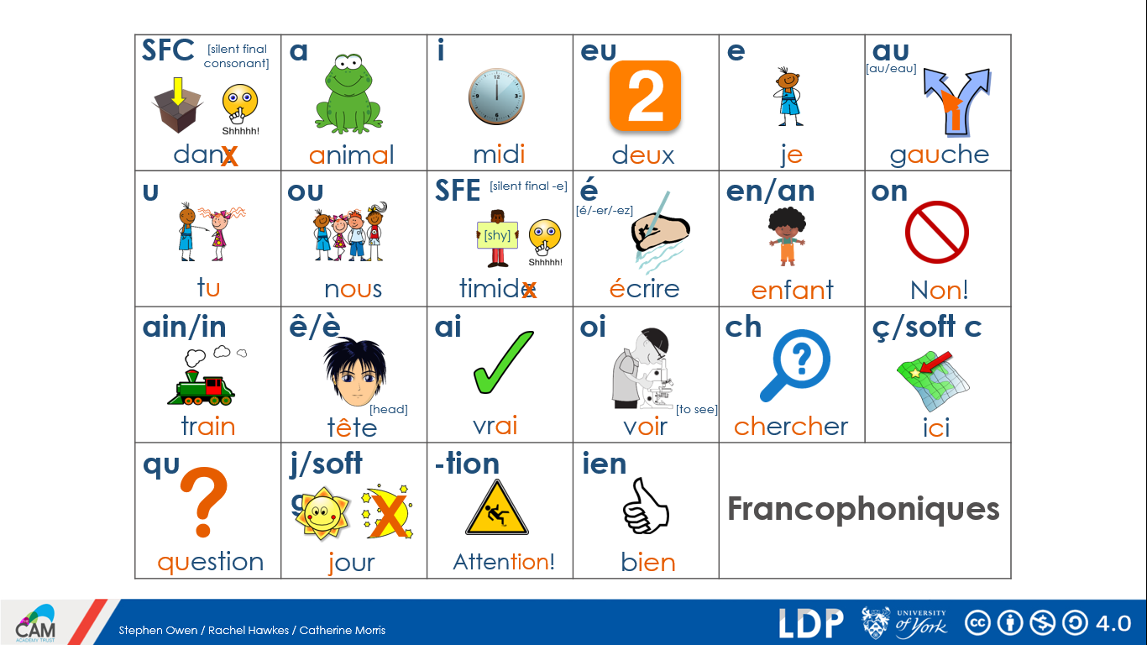
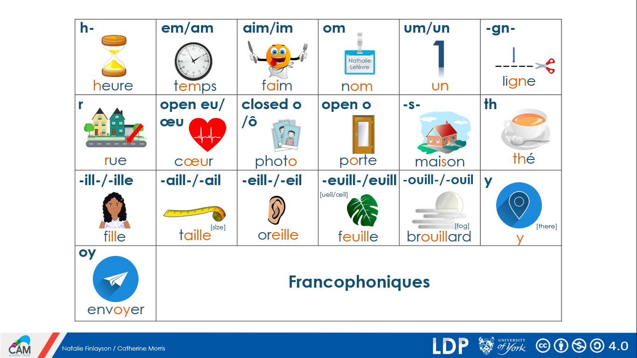
Spring Term 1 recap:
What can you remember? Complete the grid in English:
le chanteur |  | stricte
malade |  | jeune
la guitare |  | sympa
un cadeau |  | amusant/e
chez moi |  | un chat/s
un portable |  | un chien/s
en dehors |  | un poisson/s
une fête |  | un lapin/s
le matin |  | un cheval/ chevaux
Il y a |  | une maison
des |  | une voiture
une chambre |  | un problème
un ordinateur |  | grand/e
une fenêtre |  | petit/e
un |  | énorme
deux |  | un effort
trois |  | le ménage
quatre |  | la cuisine
cinq |  | car
six |  | parce que
sept |  | mais
huit |  | et
neuf |  | aussi
dix |  | le cadeau
onze |  | le français
douze |  | ça va?
content/e |  | bien
sage |  | malade

Verbs:
Regular er verbs – remove the ‘er’ and then add the following endings and learn them.
jouer = to play
Je joue = I play
Tu joues = You play (singular, informal)
Il/Elle/On joue = He/She/One plays
Nous jouons = we play
Vous jouez = You play (plural, formal)
Ils/Elles jouent = They play

Now apply this knowledge to the following verbs and write the English translation
trouver = To Find
Je trouv____ = ____________________________________
Tu trouv____ = ____________________________________
Il/Elle/On trouv____ = ____________________________________
Nous trouv____ = ____________________________________
Vous trouv____ = ____________________________________
Ils/Elles trouv____ = ____________________________________

aimer = to like
Je ____________ = ____________________________________
Tu ____________ = ____________________________________
Il/Elle/On ____________ = ____________________________________
Nous ____________ = ____________________________________
Vous ____________ = ____________________________________
Ils/Elles ____________ = ____________________________________

Irregular verbs – You must learn these!!

avoir = to have
J’ai = I have
Tu as = You have (singular and informal)
Il / Elle/ On a = he has
Nous aons = we have
Vous avez = You have (formal or plural)
Ils ont / Elles ont = They have

faire = to do/ to make
Je fais = I do/am doing
Tu fais = You do / are doing
Il/elle/on fait = He/ She/ One does / is doing
Nous faisons = We do /are doing
Vous faîtes = you do / are doing
Ils/ ells font = they do / are doing

Translate:

J’ai un frère =
Elle a un chien =
Je fais la cuisine =
Il fait les magasins =

Week 1 – Describing People
Vocabulaire
Il y a = there is
J’ai = I have
Tu as = You have
Il a = He has
Elle a = She has
C’est = It is
avec = with
ma mère = my Mum
mon père = my Dad
ma souer = my sister
mon frère = my brother
ta grandmère = your Grandmother
ton grandpère = your grandfather
sa tante = his/her aunt
son oncle = his /her uncle

Translate
- J’ai ma soeur et mon frère = _______________________________
- Tu as ta mère et ton père =_______________________________
- C’est son oncle avec sa tante =____________________________
- Ton grandpère est content =_______________________________
- Ma tante est contente =______________________________
- It is your uncle with your aunt =_____________________________
- His aunt is happy =_______________________________
- My grandad is happy =______________________________
- She has her sister and her brother =___________________

Week 2 – Places to go in town
Vocabulaire
Je vais = I go / am going
Il va = He goes / is going
Elle va = She goes / is going
e parc = the park
le college = the school
le travail = the work
le magasin = the shop
la poste = the post office
la maison = the house
la porte = the door

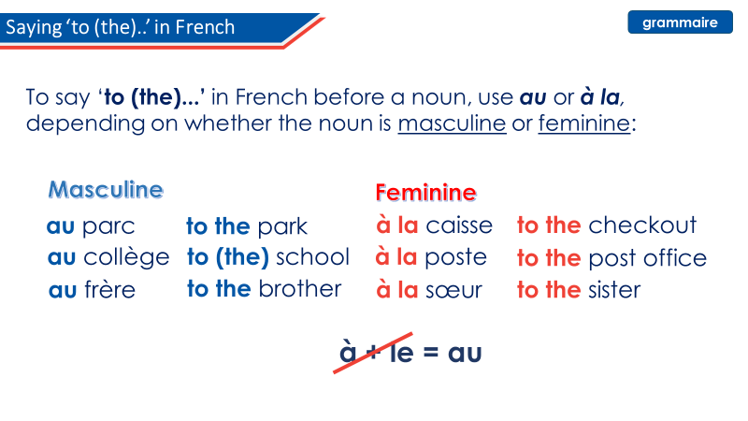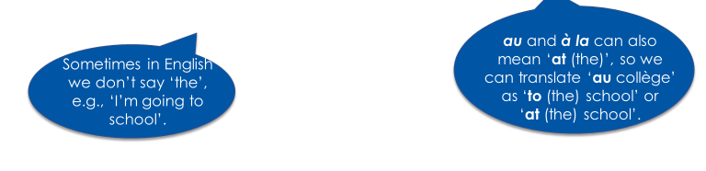

Translate
- Je vais à Paris =_______________________________
- Elle va à Rouen =_______________________________
- Je vais à la poste =_______________________________
- Il va au parc =_______________________________
- I am going to Lille =_______________________________
- She is going to Toulouse =_______________________________
- I am going to school =_______________________________
- He is going to the post office =________________________
- She is going to work =_______________________________

Week 2 – Places to go in town – Part 2
Vocabulaire
Je vais = I go / am going
Tu vas = You go / are going
Il va = He goes / is going
Elle va = She goes / is going
où = where?
comment? = how?
quand? = when?
le collège = school
la poste = the post office
le parc = the park
chaque semaine = each / every week
la maison = the house / home

Translate

Tu vas au collège comment ? = ________________________
Elle va à la poste comment ? = _________________________
Tu vas où chaque semaine ? = _________________________
Je vais au parc quand ? = _____________________________
Tu vas à la maison? = ________________________________

Week 3 – Where people go (on holiday)
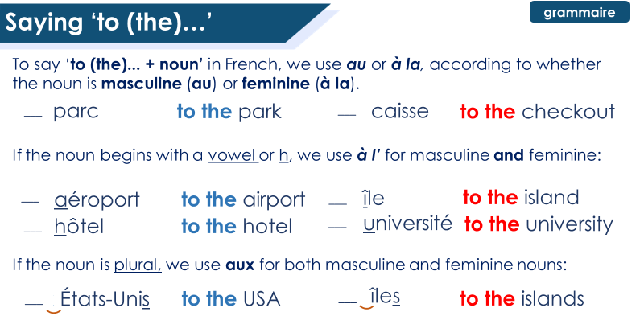
Vocabulaire
Je vais = I go / am going
Tu vas = You go / are going
Il va = He goes / is going
Elle va = She goes / is going
aux hôtels = to the hotels
à l’étranger = abroad
aux îles = to the islands
à l’aéroport = to the airport

Translate
Je vais aux hôtels. =_______________________________
Il va à l’étranger. =_______________________________
Tu vas aux îles. =_______________________________
Il va à l’aéroport. =_______________________________

Week 4 – Family
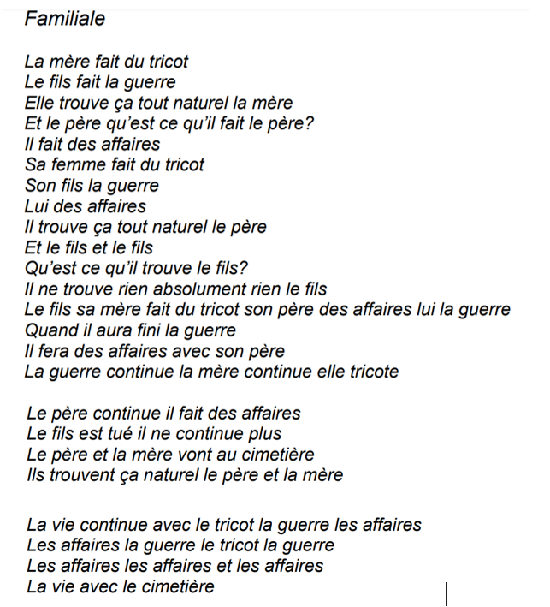

Vocabulaire
aller au cimetière = to go to the cemetery
faire des affaires = to do business
faire du tricot = to do knitting
faire la guerre = to make war
la liberté = freedom
la justice = justice
l’autorité = authority
la guerre = war
tuer = to kill
le fils = the son
la vie = the life

Find the line in the text:
The mum does the knitting =_______________________________
The son goes to war =_______________________________
The war carries on =_______________________________
The son is killed =_______________________________
The mum and dad go to the cemetery =_________________________
Life carries on =_______________________________

Week 5 – Where people go
Vocabulaire
Je vais = I go / am going
Tu vas = You go / are going
Il va = He goes / is going
Elle va = She goes / is going
Nous allons = we go / are going
Vous allez = you go / are going
Ils vont = they go / are going
Ells vont = they go /are going
au parc = to the park
aujourd’hui = today
souvent = often
à la poste = to the post office
rarement = rarely
aux États-Unis = to the United States
au collège = to school
chaque jour = every day
souvent = often
aux magasins = to the shops
à Londres = to London
aujourd’hui = today

Translate
I am going to the park today. =_______________________________
We often go to the post office. =_______________________________
He rarely goes to the USA. =_______________________________
We go to school every day. =_______________________________
Do you go to the shops often? =_______________________________
We are going to London today. =_______________________________
They are going to Lille. =_______________________________

Week 6 – Where people go (countries)
Vocabulaire
Quoi? = what
Nous cherchons = we are looking for
Londres = London
la France = France
l’Écosse = Scotland
l’Angleterre = England
les vacances = holidays
chez = at the house of/ at the place of
la ville = the town
une année = a year
un mois = a month
le médecin = the Doctor’s

Translate
- We are looking for London =_______________________________
- We are looking for Scotland =_____________________________
- We are looking for the town =_____________________________

Go back to the grammar re-cap on Week 3 to answer the next sentences. Which is correct and then translate.

- Je vais à Paris/parc = _________________________________
- Il va à caisse/ Lille = _________________________________
- Elle va au collège/Londres =______________________________
- Tu vas aux Edimbourg / États-Unis =_________________________
- Il va à Marseille / France =_________________________________

