Nom:

Year 8 French


Autumn Term 2
Workbook

Top tips for success in French:

- Learn vocabulary on a regular basis – little and often is usually best
- Think about how sentences string together with the grammar rules that you learn in class
- Practice your phonics regularly as this will be tested in exams too
- Make sure you find opportunities to listen to French (podcasts, films, YouTube videos, music)

- Complete this booklet (with your teacher’s instruction) to the best of your ability and don’t skip any questions!

- You may need to refresh your memory and look back at previous pages to find the vocabulary you need.

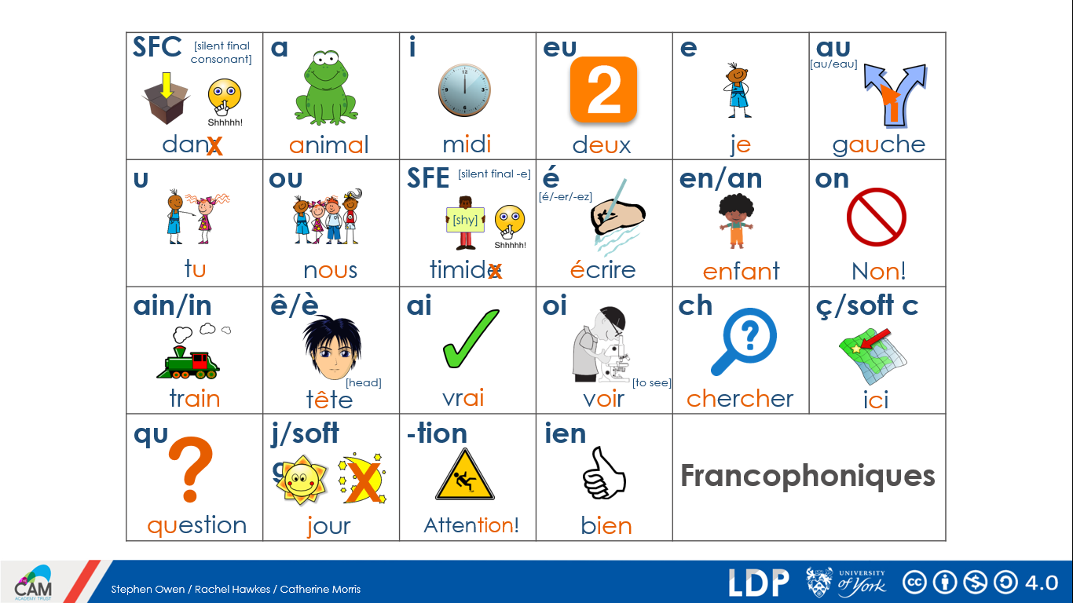
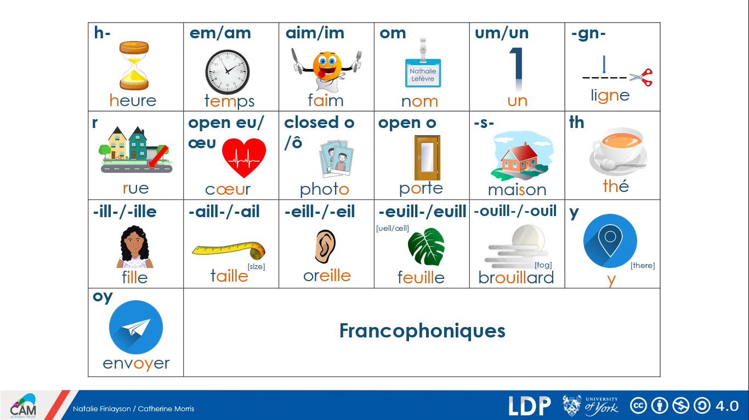
Autumn Term 1 recap:
What can you remember? Complete the grid in english:
être |  | le papillon
suis |  | le sable
est |  | unique
es |  | genial
je |  | expliquer
elle |  | manquer
tu |  | la bouche
il |  | le champ
grand |  | un voyage
calme |  | Londres
encore |  | mauvais
penser |  | j’ai
continuer |  | tu as
un enfant |  | la maison
un garçon |  | la médaille
une chose |  | une semaine
une chambre |  | pourquoi?
le monde |  | j’aime
le fin |  | tu aimes
le matin |  | il aime
le college |  | porter
la main |  | je porte
le ménage |  | la raison
le lit |  | le cadeau
je fais |  | aujourd’hui
faire |  | rien
une question |  | chaque
un jour |  | froid
une équipe |  | le prix
travailler |  | regarder
je travaille |  | je regarde
Week 1
Activities in and out of school: Saying what others do
Words seen previously
 | Word | French meaning
1 | red
2 | blue
3 | yellow
4 | purple
5 | green
6 | pink
7 | black
8 | white
9 | grey
10 | brown
un animal = an animal
un sac = a bag
une table = a table
le chanteur = the singer (masc.)
la chanteuse = the singer (fem.)
ça va? = how are you ?
malade = ill

étudier = to study
jouer = to play
trouver = to find
écouter = to listen
ER Verbs
 | French | English meaning
1 | Je joue
2 | Tu joues
3 | Il/elle joue
4 | J’écoute
5 | Tu écoutes
6 | Il/elle écoute
7 | Nous écoutons
8 | J’étudie
9 | Tu étudies
10 | Il/Elle étudie
11 | Je chante
12 | Elles chantent
13 | Je prépare
14 | Ils préparent
préparer = to prepare
en ce moment = at this moment

la guitare = the guitar
la radio = the radio
je = I
tu = you
il = he
elle = she
nous = we
vous = you (pl)
ils/elles = they

Week 2
Activities in the holidays
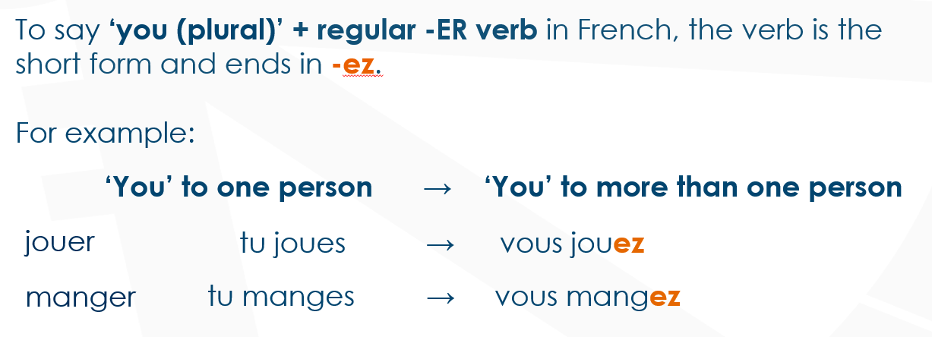
Vocabulaire
 | Français | Anglais
1 | donner un cadeau à
2 |  | to watch a film
3 | étudier chez moi
4 | organiser une activité
5 |  | to sing
6 |  | to prepare the lunch
7 | marcher en dehors
8 |  | to listen to the radio
9 |  | to find a present for
10 | demander un portable comme cadeau
11 | jouer un jeu
12 |  | to organise a party

Vocabulaire
vous marchez = you walk/are walking
vous donnez = you give/are giving
vous organisez ? = are you organising ?
je joue = I play/am playing
j’écoute = I listen to/am listening to
en dehors = outside
normalement = normally
le matin = (in) the morning
une fête = a party
un jeu = a game
un cadeau = a present
à = to
votre père = your Dad
Translate
1) You go for a walk outside = ____________________________________
2) Normally I play a game with my family = ____________________________
3) Are you organising a party? = __________________________________
4) I listen to the radio in the morning = ________________________________
5) You give a present to your Dad = _________________________________
Week 3
Family and Family Life: Saying how many there are

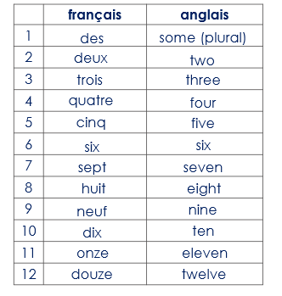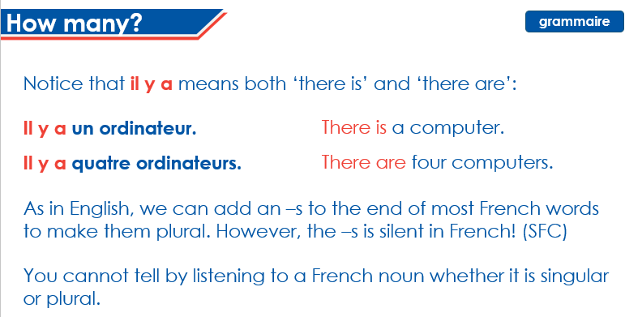
Vocabulaire
Il y a = there is/ there are
Je regarde = I watch/I am watching
une chambre = a bedroom
un ordinateur = a computer
une fenêtre = a window
les girafes chics = the stylish giraffes
à la maison = at home
chez moi = at home
dans la salle de classe = in the classroom
en Martinique = in Martinique

Translate
1) Il y a six chambres à la maison = _________________________________
2) Je regarde onze télés = ____________________________________________
3) There are seven computers in the classroom = _______________________________________________________________________
4) There is a window at home = ______________________________________
5) There are 3 stylish giraffes in Martinique = _________________________________________________________________________
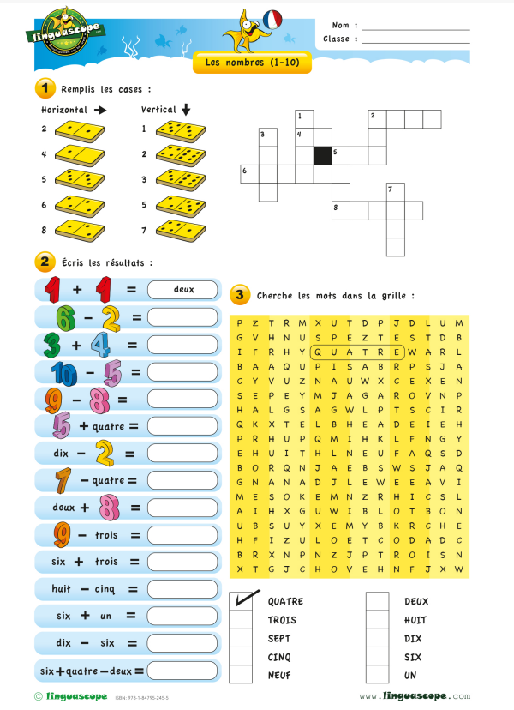

Week 4
Family and Family Life: Describing people

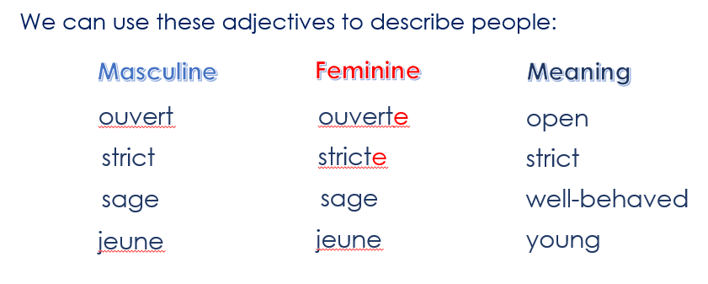
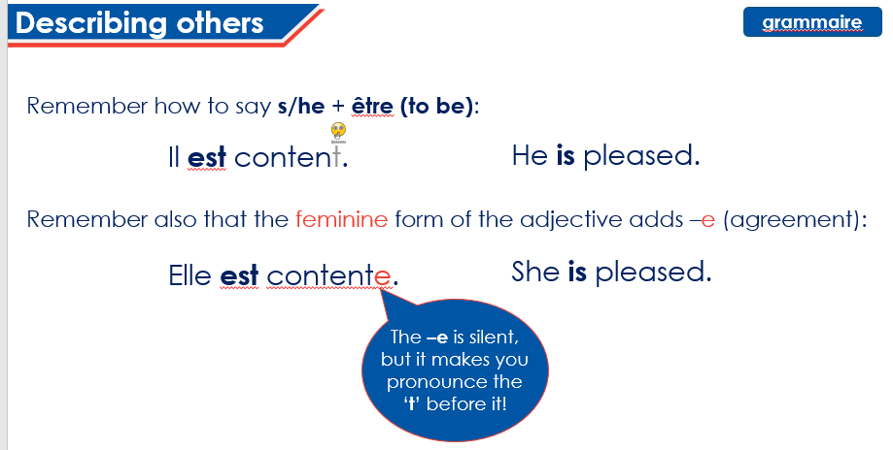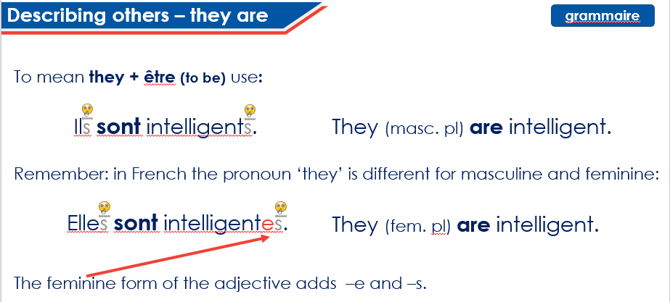

Vocabulaire
Je suis = I am
Il est = He is
Elle est = She is
Ils sont = They are
Elles sont = They are
madame = Mrs
monsieur = Mr
sage = well-behaved
stricte = strict
jeune = young
intelligent = intelligent
amusant = funny
sympa = nice
Translate
1) I am well-behaved (f) = __________________________________________
2) Mrs Harris is strict = _______________________________________________
3) He is young = ______________________________________________________
4) Laura and Louise are intelligent and funny = * (watch out for agreements) _______________________________________________________________________
5) He is nice = _________________________________________________________

Week 5
Family and Family Life: Saying what people have
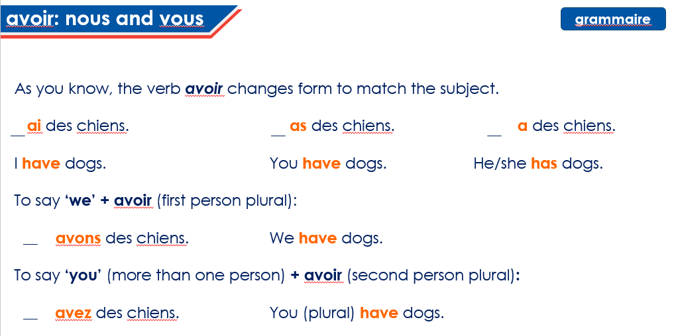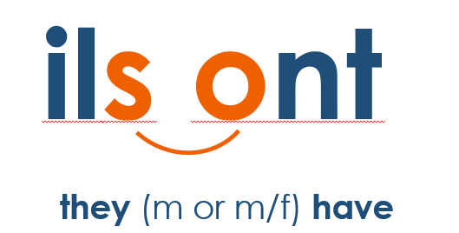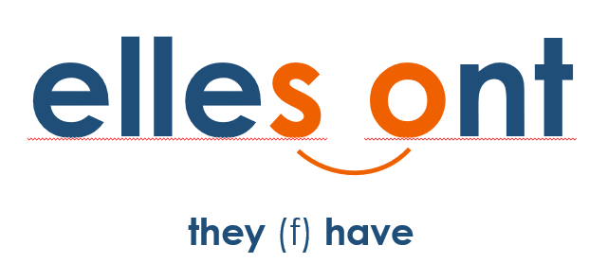
Vocabulaire
J’ai = I have
Tu as = You have (singular and informal)
Il a = he has
Elle a = she has
Nous avons = we have
Vous avez = You have (formal or plural)
Ils ont = They have
Elles ont = They have
un chat/s = a cat/s
un chien/s = a dog/s
un poisson/s = a fish/fish
un lapin/s = a rabbit/s
un cheval/ chevaux = a horse/s
une maison = a house
une voiture = a car
un problème = a problem
grand/e = big
petit/e = big
énorme = huge

Translate * (watch out for agreements)
1) I have two dogs and three cats =
2) He has seven fish, eight rabbits and nine horses =
3) You (polite) have a big house =
4) They (f) have a small car =
5) You (singular) have a huge problem =
