Nom:

Year 8 French


Autumn Term 1
Workbook

Top tips for success in French:

- Learn vocabulary on a regular basis – little and often is usually best
- Think about how sentences string together with the grammar rules that you learn in class
- Practice your phonics regularly as this will be tested in exams too
- Make sure you find opportunities to listen to French (podcasts, films, YouTube videos, music)

- Complete this booklet (with your teacher’s instruction) to the best of your ability and don’t skip any questions!

- You may need to refresh your memory and look back at previous pages to find the vocabulary you need.

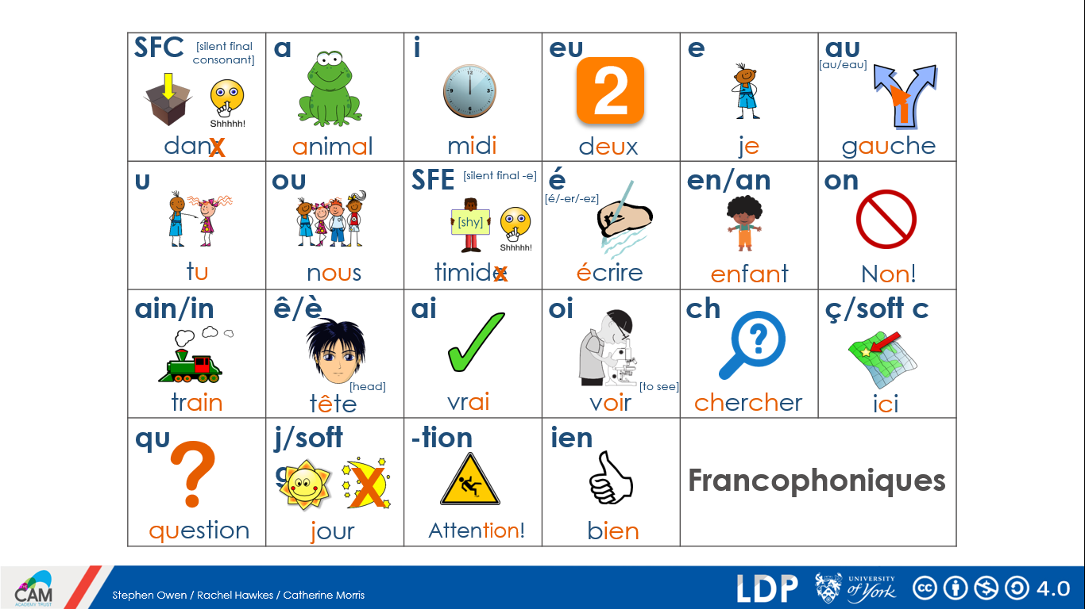
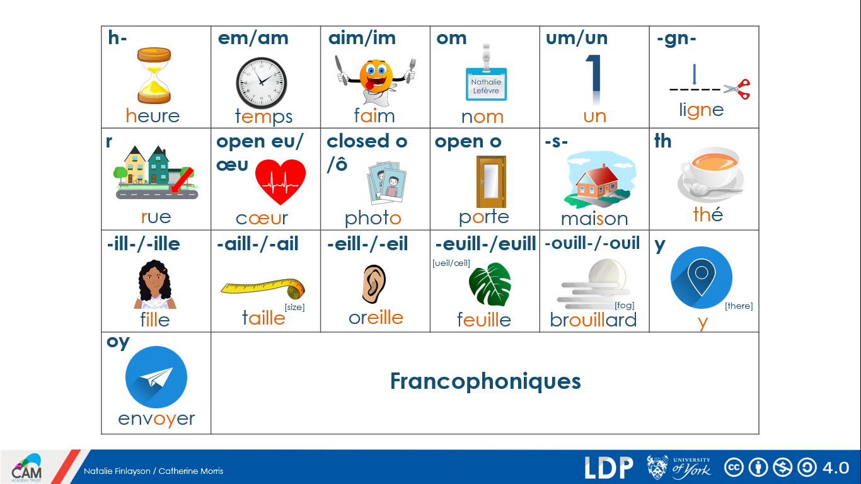
Year 7 recap:
Describing a thing or person

être to be / being
es are
est is
suis am

je I
il he
elle she
tu you
 | Word | English meaning
1 | être
2 | es
3 | est
4 | suis
5 | anglais
6 | cool
7 | français
8 | grand
9 | petit
10 | et

anglais English
français French
grand tall / big
petit small / little
cool cool
et and

au revoir goodbye
bonjour hello
oui yes
non no

 | Sentences: Translate
1 | I am French -
2 | He is small -
3 | She is tall -
4 | You are English -
5 | I am English and small -
6 | She is French -
7 | He is tall and English -
8 | I am tall -
9 | She is English and small -
10 | You are small and French -
Describing a thing or person
être to be / being
es are
est is
suis am

aimable nice / kind
 | Word | English meaning
1 | triste
2 | intelligent
3 | calme
4 | content
5 | excellent
6 | amusant
7 | et
8 | malade
9 | ou
10 | méchant
amusant funny
calme quiet
content happy
excellent excellent
intelligent intelligent
malade ill
méchant naughty / nasty

mais but
ou or

voilà here (it) is…
merci thank you

 | Sentences: Translate
1 | I am intelligent -
2 | He is quiet -
3 | She is happy -
4 | I am intelligent but nasty -
5 | He is ill -
6 | She is funny and sad -
7 | I am small and quiet -
8 | He is tall but naughty -
9 | Being naughty is funny! -
10 | Being funny is excellent -

Saying what people have
a has
ai have
avoir to have / having
 | Word | English meaning
1 | avoir / a / ai
2 | un chien
3 | un animal
4 | une idée
5 | qui
6 | une chose
7 | une chambre
8 | un portable
9 | un livre
10 | une règle
ce (c') it
c’est it is
elle she
il he

un animal a pet / an animal
une chambre a bedroom
un chien a dog
une chose a thing
une idée an idea
une liste a list
un livre a book
un portable a mobile phone
une règle a ruler
un bateau a boat
un cadeau a present

un a / an (masculine nouns)
une a /an (feminine nouns)
qui who / which / that
écris/parle en anglais write / speak in English

 | Sentences: Translate
1 | He has a thing. –
2 | It is good. -
3 | It is a list. –
4 | It is also sad. -
5 | He is quiet. -
6 | The water is good. -
7 | Who is sad? -
8 | I am intelligent. -
bon good
triste sad
gauche left
faux false
aussi also
beau nice
l’eau water

Identity – belongings
je I
tu you
nous we
 | Word | English meaning
1 | Je suis
2 | J’ai
3 | rapide
4 | nous
5 | amusant
6 | oui
7 | cher
8 | un livre
9 | elle a
10 | tu as
salut! Hi!
J’ai I have
Il a He has
Elle a She has
Tu as You have

Je suis I am

amusant funny
cher expensive (m)
chère expensive (f)
modern modern
rapide fast/quick

utiliser to use/using
trouver to find/finding
jouer to play/playing

sur on
toujours always/still
oui yes
 | Sentences: Translate
1 | I have a boat. -
2 | It is false. -
3 | He has an animal. -
4 | She has a dog. -
5 | Having a present is nice. -
6 | The book is sad. -
7 | I have an idea. -
8 | You have a mobile phone. -
non no

un ordinateur a computer
un vélo a bike
un livre a book
une vue a view
une voiture a car

Identity – describing a friend
Je suis I am
Tu es You are
Il est He is
 | Word | English meaning
1 | froid
2 | il est
3 | un ami
4 | un homme
5 | aussi
6 | le pont
7 | vrai
8 | je suis
9 | parfois
10 | souvent

timide shy
modern modern
froid cold
drôle funny
vrai true
intéressant interesting

sympa nice
vrai true
faux false

le monde the world
le prix the prize
le loup the wolf
le riz the rice
la soupe the soup
le pont the bridge
le centre the centre/middle
la vie the life
 | Sentences: Translate
1 | It is cold. -
2 | I am nice. -
3 | I am funny. -
4 | You are a man. -
5 | She is a woman. -
6 | The world is big. -
7 | I have a friend. -
8 | He is sometimes nice. -
la pelouse the lawn
la cuisine the kitchen
la aube the dawn

un professeur a teacher
un homme a man
un chanteur a singer
une femme a woman
un ami a friend

souvent often
parfois sometimes
aussi also
très very

aller to go/going
donner to give/giving
parler to speak/speaking

Autumn Term 1
Week 1 – Identity: Describing others
grand tall/big
drôle funny
calme calm
encore again
dangereux dangerous
 | Word | English meaning
1 | drôle
2 | un garçon
3 | le pont
4 | une fille
5 | est
6 | prendre
7 | dangereux
8 | calme
9 | un chien
10 | une femme

penser to think/thinking
prendre to take/taking
continuer to continue/continuing
montrer to show/showing

un enfant a child
un chien a dog
un livre a book
un garçon a boy
un portable a phone
une chambre a bedroom
 | Sentences: Translate
1 | The girl is calm -
2 | I am tall. -
3 | The bridge is big. -
4 | A boy is dangerous. -
5 | She is calm. -
6 | The world is dangerous. -
7 | I have a bedroom. -
8 | I have a child. -

une chose a thing
une femme a woman
une fille a girl
le monde the world
le pont the bridge

quand? when?
au fond basically
dans in
sans without

le/la the
un/une a
est is
Week 2 – Doing and making things

le fin end
 | Word | English meaning
1 | le lit
2 | le magasin
3 | le main
4 | la tête
5 | les courses
6 | les devoirs
7 | je fais
8 | elle fait
9 | maintenant
10 | la cuisine
le main hand
le matin morning
le magasin shop
le gant glove
le college school
le frère brother
le niveau level
le ménage housework/chores
 | Sentences: Translate
1 | I do the shopping. -
2 | He does the shopping. -
3 | I do homework. -
4 | The party is big. -
5 | The brother is funny. -
6 | The school is big. -
7 | I have a brother. -
8 | I have homework. -
le lit bed
la couronne crown
la tête head
la cuisine kitchen/cooking

la fête party/celebration
les courses shopping
les devoirs homework

faire to do, to make/doing,making
fait does,makes/is doing,is making
je fais I do/make
tu fais you do/make
il fait he does/makes
elle fait she does/makes
être to be/being

maintenant now
Week 3 – Doing and making things

un question question
un jour day
une équipe a team
 | Word | English meaning
1 | un jour
2 | la ville
3 | la Afrique
4 | vert
5 | le papillon
6 | la musique
7 | bleu
8 | rouge
9 | quatre
10 | nager

le pays country
le papillon butterfly
le sable sand
l’équipement(m) equipment
la musique music
la ville town/city
la quantité quantity
la requête request

la Afrique Africa
 | Sentences: Translate
1 | It is unique! -
2 | The butterfly is blue. -
3 | Mexico is big. -
4 | I have 4 butterflies. -
5 | The sand is dangerous. -
6 | I have a question. -
7 | The town is big. -
8 | Swimming is great. -
la Jamaïque Jamaica
le Mexique Mexico

unique unique
génial great
vert green
bleu blue
rouge red
quatre four

expliquer to explain/explaining
manquer to miss/be missing
nager to swim/swimming
Week 4 – Saying what people do

 | Word | English meaning
1 | le chat
2 | les magasins
3 | un voyage
4 | je fais
5 | il fait
6 | Londres
7 | ici
8 | parler
9 | mauvais
10 | les devoirs
la bouche mouth
la cuisine food
le chat cat
le champ field
le lit bed
les devoirs homework
les magasins shopping
un voyage a trip
un garçon a boy
 | Sentences: Translate
1 | I do homework. -
2 | You do homework. -
3 | London is bad. -
4 | The boy is big. -
5 | I do shopping. -
6 | I have a bed. -
7 | The field is small. -
8 | It is here. -

chercher to look for
chanter to sing/singing
decider to decide/deciding
parler to speak/speaking
faire to do/to make

je fais I do/I make
tu fais You do/you make
il fait he does/he makes
elle fait she does/she makes

dimanche Sunday
Londres London
mauvais bad
beau nice
ici here
cinq five
Week 5 – Saying what people do

 | Word | English meaning
1 | trois
2 | une semaine
3 | aimer
4 | J’aime
5 | vrai
6 | Je porte
7 | voir
8 | pourquoi?
9 | avoir
10 | Elle aime
la maison house
la médaille medal
la raison reason
le camp camping
l’uniforme uniform
une semaine week

vrai true/right
parfait perfect
 | Sentences: Translate
1 | He likes London. -
2 | I like the cat. -
3 | The uniform is great. -
4 | The reason is bad. -
5 | I wear blue, -
6 | I like wearing… -
7 | I have a medal. -
8 | I like the house. -
trois three
pourquoi? Why?

aimer to like/liking
J’aime I like
Tu aimes You like

Il aime He likes
Elle aime She likes

porter to wear/wearing
Je porte I wear/ I am wearing
Tu portes You wear/You are wearing
Il porte He wears/He is wearing

voir to see
avoir to have
trouver to find

Week 6 – Talking about actions to others

l’action action
 | Word | English meaning
1 | le cadeau
2 | ancient
3 | combien?
4 | Je donne
5 | le chien
6 | rien
7 | avoir
8 | Elle donne
9 | chaque
10 | bientôt
la solution solution
la raison reason
le cadeau present
le chien dog
l’exemple example

aujourd’hui today
normalement normally
bientôt soon
rien nothing
ancien old
chaque each
combien? how much/many?
 | Sentences: Translate
1 | It is old. -
2 | She gives nothing. -
3 | It is soon. -
4 | The present is how much?
5 | Today is good. -
6 | The dog is small. -
7 | The example is here. -
8 | I like to think. -

en ce moment at the moment
que that
à at/to/of

demander to ask for
donner to give/giving
Je donne I give
Elle donne she gives

penser to think/thinking
montrer to show/showing
avoir to have
Week 7 – Saying what you do with others

froid cold
 | Word | English meaning
1 | froid
2 | les films
3 | manger
4 | Je mange
5 | Je travaille
6 | le prix
7 | timid
8 | regarder
9 | Nous mangeons
10 | travailler
timid(e) shy

trente thirty

la soupe soup
la télé TV
le prix price
le film film
les films films

manger to eat/eating
travailler to work/working
regarder to watch/watching

 | Sentences: Translate
1 | We watch the TV. -
2 | I eat soup, -
3 | We eat soup. -
4 | I am working today. -
5 | The soup is bad. -
6 | I am shy. -
7 | He is cold. -
8 | Today is Sunday. -
Je regarde I watch
Je travaille I work
Je mange I eat

Nous regardons We watch

Nous travaillons We work
Nous mangeons We eat

