FOUNDATION OF LIGHT
National Citizen Service
Information Handbook
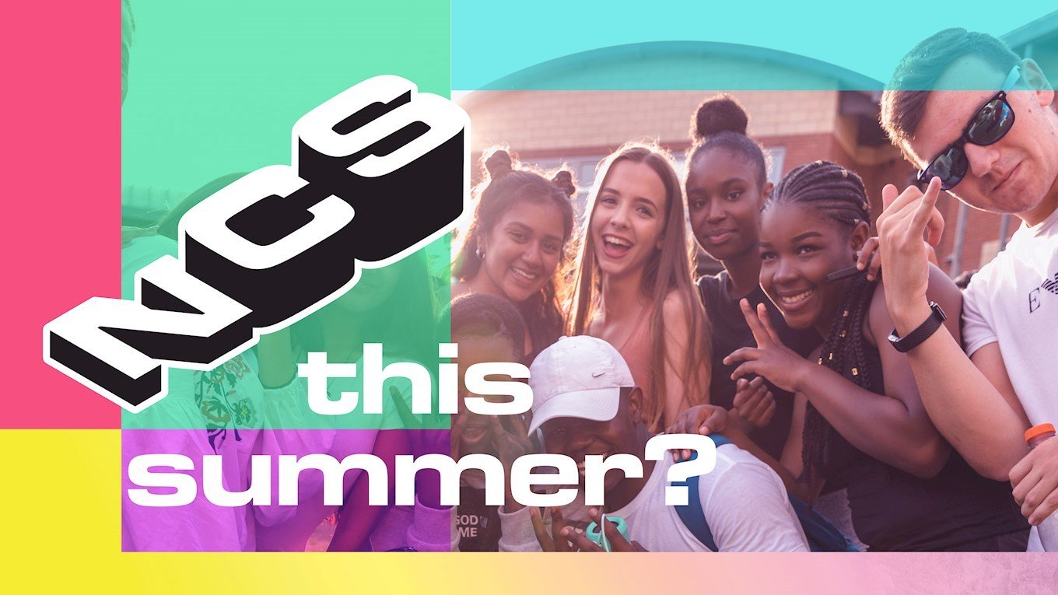
SUMMER 2021
Join us!

Table of Contents

- Welcome letter
- About NCS including FOL testimonials and videos
- Social Media
- Data Protection, Safeguarding and Prevent
- How To Sign up
- Expression of Interest form
- Foundation of Light Consent form
- NCS medical form
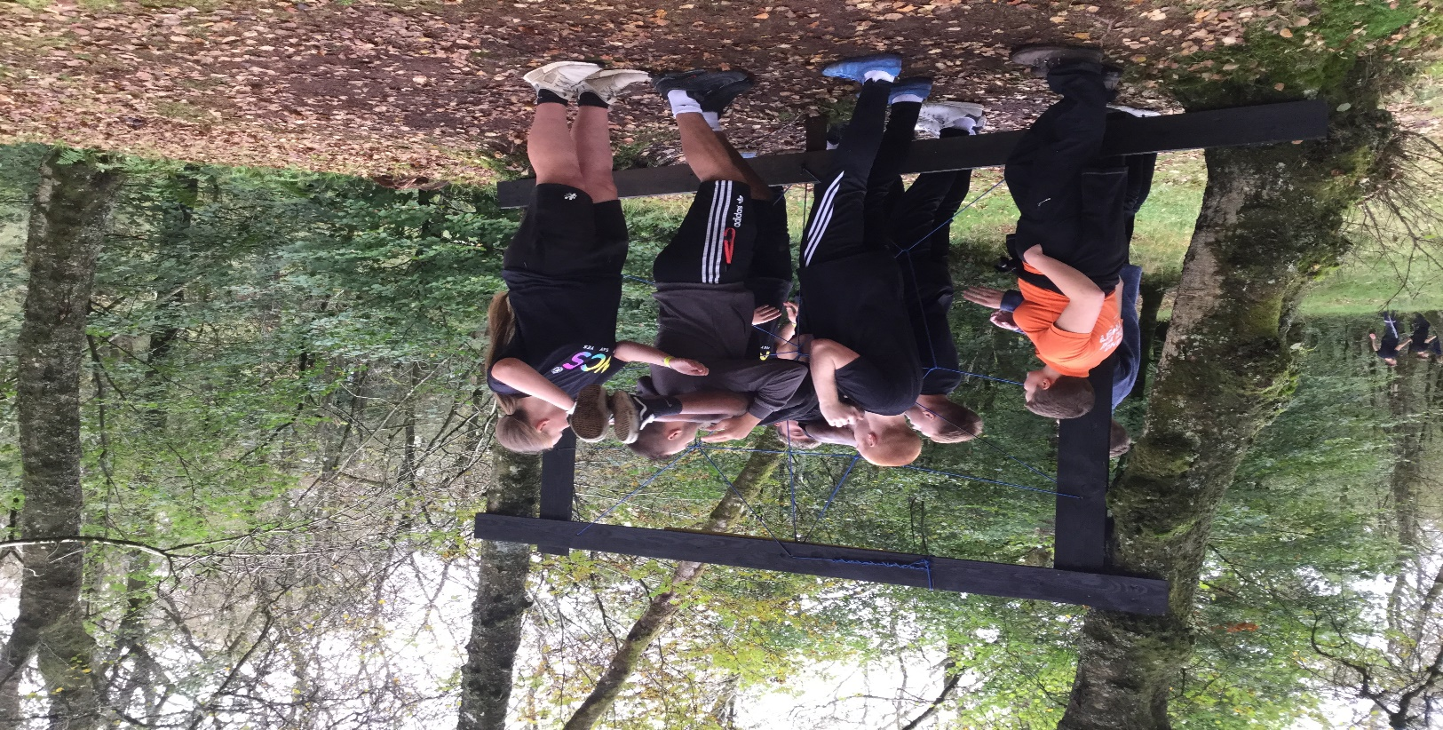

Welcome letter

Dear parent/guardian,
During the Summer of 2021 we have a fantastic opportunity for your children. As a national youth programme, NCS is made up of lots of regional providers – and that’s where we come in. (Hello!) We are the Foundation of Light and we’re your local NCS provider. Summer 2020 programme was altered due to COVID-19 which makes us even more keen to ensure that the Summer of 2021 will be an epic experience for the young people in our schools.
The Foundation of Light will be working with local schools in the Sunderland area to offer this experience both in schools and over our social media channels. This is a little overview of who we are and what we’re about…
NCS is an experience specially designed for 16-17-year olds. We give young people four weeks out over the summer holiday to meet new people, try new things and cover new ground. We’re all about helping teenagers realise their potential, by giving them a taste for independence and loading them up with new skills so they can go on to smash their future goals. NCS is a brilliant way to enhance the skills your children already have and build exciting new ones. The programme offers amazing chances to build a positive CV and personal statement and assist them with the next steps in their lives.
Technically a spot on our four-week programme costs around £1,500 but because we’re government-funded, we only ask for a contribution. The most you’ll pay is £50, and we also offer bursaries – so everyone can do NCS. If your teenager is on free school meals, the care system or pupil premium, then the price could be further reduced to £25.
Summer 2021 is a brilliant opportunity to bridge the gap between leaving school and the next stage in their lives.
We will be in touch once we have specific dates for our Summer programmes.
Kind Regards
Craig Martin – NCS Manager, Foundation of Light

About NCS
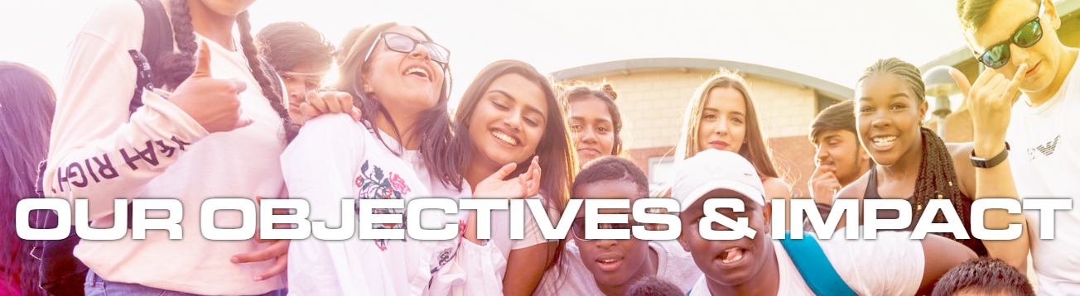

SOCIAL COHESION
Cultivating stronger, more integrated communities by fostering understanding between you and your neighbours from different backgrounds.

SOCIAL MOBILITY
Building essential skills for work and life, making sure you can get ahead and are prepared for whatever the future holds – think of it as investing in our country’s future talent.

SOCIAL ENGAGEMENT
Engaging you in social action in your community as well as the democratic process, creating more understanding of your responsibilities as a citizen and your potential to affect change.

The four Phases of NCS

PHASE 1 – BE EPIC
This phase is about bonding with your team and getting to know each other.
Young people will spend 5 days away from home and out of their comfort zone in a week of outdoor experiences and opportunities to develop confidence, leadership and teamwork skills.

PHASE 2 – LIVE LIFE
The second residential of the programme involves five days in the University of Sunderland Halls of residence where participants learn independent living skills and gain career and health advice from local providers and professionals.

PHASE 3 – DO GOOD
Involves a two-week period of developing social action projects to give back to the local community. In this period participants work in small teams to plan, develop and run a sponsored event raising money to deliver a local community project.

PHASE 4 – GO PARTY
This is an opportunity to celebrate your NCS achievement in a graduation event at the Beacon of Light alongside all the other NCS graduates.

About NCS
NCS promotes young people to develop self-belief, confidence and interpersonal skills and as part of their ‘NO WE CAN’ approach promotes this throughput all four phases of the programme. To see the NCS advertisement and also the phase videos of an NCS programme then select the links below.
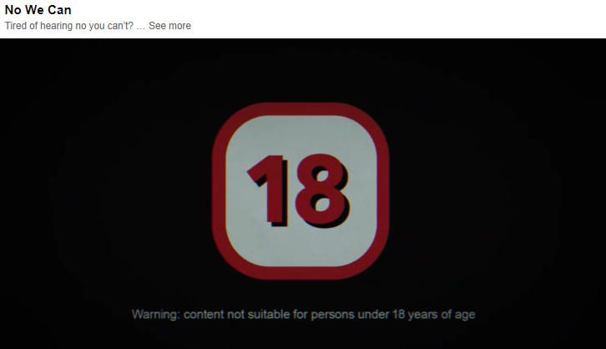

https://www.facebook.com/watch/?v=3331224073584316

The NCS Experience: Step-by-Step
https://www.youtube.com/playlist?list=PLct9oPGud0dOfgjyxY4jSqy8lxTkXkQMB


FREQUENTLY ASKED QUESTIONS
We have tried to list the most popular questions asked by young people. Sometimes reluctance to ask these can make the difference between giving the programme a chance.
Question | Answer
How much does NCS cost? | Dependent on your circumstances this can change but the maximum you will ever pay is £50
What does the cost cover? | Phase 1 – NCS Covers all accommodation, travel, main meals and activities  Phase 2 – NCS covers all accommodation, travel, main meals and activities  Phase 3 – NCS cover all of the activities  Phase 4 – NCS cover the cost of the graduation event
Do I have to do all 4 weeks? | Yes, you do, by taking part in the whole experience you will gain different skills from each phase. Quite often young people get the most from phases they expected to get the least from.
Can I be with my friends? | NCS is all about meeting new people and expanding social circles however we will wherever possible place you with a friend. You will be in a team of 16 young people which where possible will be equal boys/girls. Some may be from your school, but this depends on which dates people choose to go.
Will I be forced to do all the activities? | Absolutely not – NCS is designed to challenge you and try to get you to move out of your comfort zone. We will motivate, empower, and encourage of course but never force.
Can I take my phone and will there be Wi-Fi | Yes of course you can take your phone, we cannot guarantee wi-fi at any point as this is at the discression of where we are staying. We hope you will not need it and only use your phone to ring parents/carers as you will be busy with your team.
What if I have heard that other people had a negative experience? | NCS is different for every person, if you come in with a positive attitude and want to make the most of it then you will. Whatever you have heard you will be in different places than them, with different people and will have different experiences.
What If I have a medical issue/illness or disability? | NCS will always attempt to be inclusive, just give us plenty of notice and we will do everything in our power to ensure you have the best experience possible.
What if I change my mind? | Then that is also ok, but please speak to staff, if something is worrying you, we may be able to help. Once you pay you get 14 days to change your mind and get a full refund.

Meet the Foundation of Light NCS team
NCS OFFICER  RYAN LISTER  Ryan has worked for the Foundation for five years and has four years’ experience of working with young people, residentials and is a qualified Level 2 Youth Worker. Ryan is passionate about making a difference to the lives of young people. | 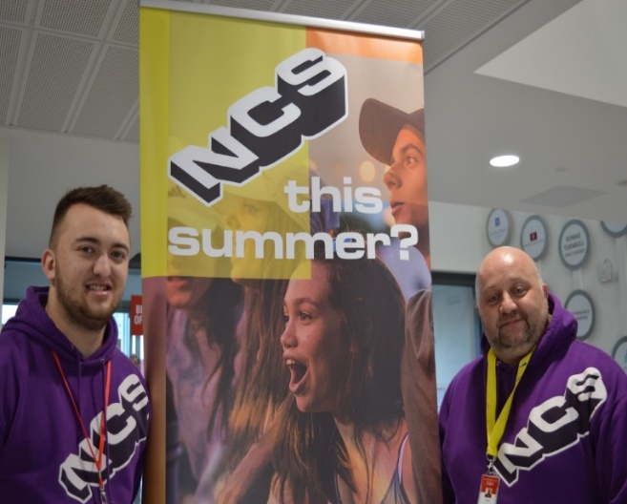 | NCS MANAGER  CRAIG MARTIN  Craig has worked for the Foundation for 18 years and has a wealth of experience in working with teenagers’ being a youth worker, coach and teacher. He has managed several projects in this time and prides himself on being creative and innovative.

SAFC Players support National Citizen service programme.
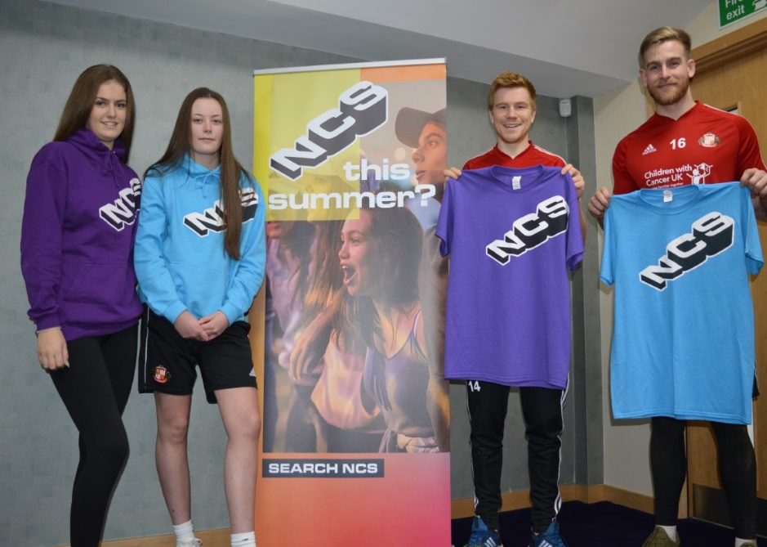
Sunderland AFC forward, Duncan Watmore said “I have heard great things about the NCS programme. It’s a fantastic opportunity for young people to get involved and try something which they thought they may never do. A chance to enjoy new experiences, make new friends and make lasting memories.”
‘NCS is designed to encourage young people to challenge themselves. We want them to use their NCS experience as a steppingstone to enhance future learning and career opportunities and to be the best they can be’ Foundation of Light NCS Manager – Craig Martin
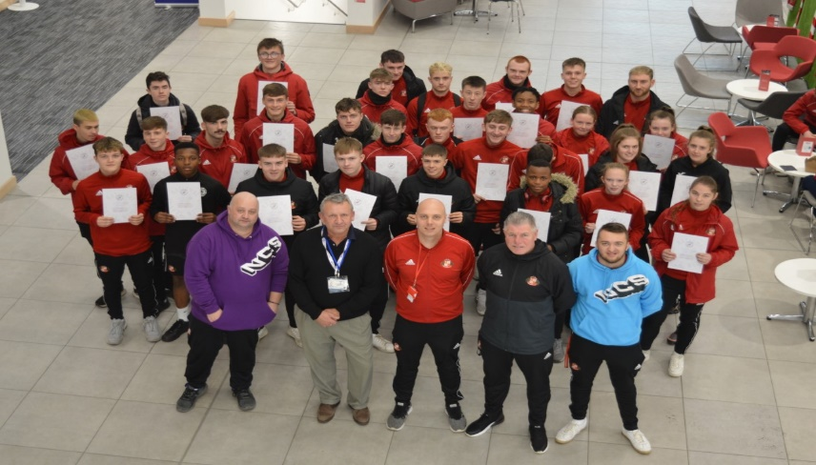
In October 2019, 52 of our scholarship students engaged in our NCS Autumn programme, they had a great week at Whithaugh Activity Centre before engaging in our skills week and carrying out some brilliant social action projects. The picture shows some of them with their certificates along with Foundation staff and partners from the EFL trust.

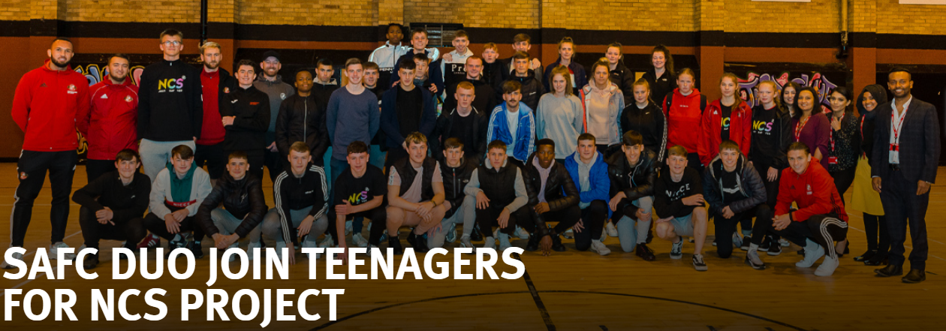
NCS Social Action Projects
Sunderland AFC’s Joel Lynch and George Dobson joined a group of teenagers taking part in the Autumn National Citizen Service (NCS) project recently to see how they think Sunderland could become a better place to live for everybody. George (the Foundation’s NCS Ambassador), Joel, NCS participants and members of Young Asian Voices community group took part in a workshop focusing on addressing community cohesion and integration. The group was set a task to collect information regarding local charities and discuss how they could link a social action project to helping a cause. Teenagers on the NCS programme chatted with players about their work, including a project highlighting their favourite things about living in Sunderland and what they think could be done to improve it.
‘It was great to come to here and visit the project. As an ambassador to witness first-hand the impact the project can have on the local community and on the teenagers is very fulfilling.’
George Dobson, Sunderland AFC Midfielder.
Over the year NCS will help hundreds of teenagers develop and grow. Many who have just left school are still unsure what they want to do with their lives and projects like this is ideal, as it can have a positive effect their local community and show how they can influence change in their neighbourhoods.
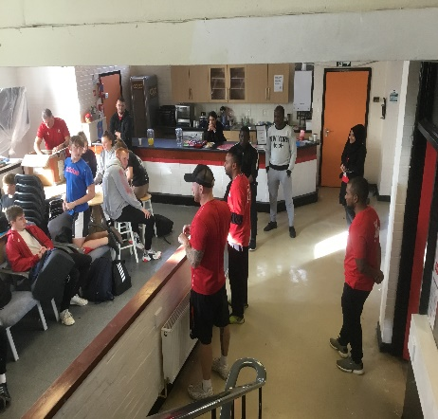
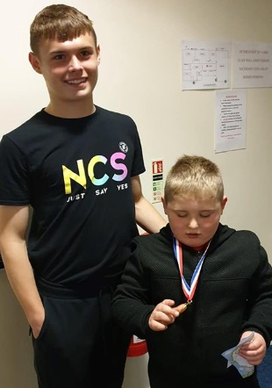
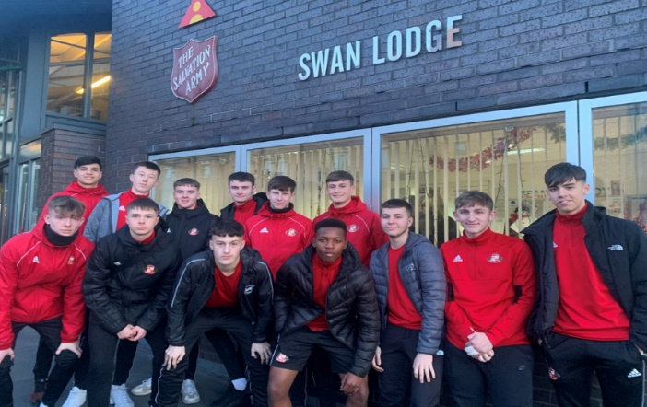
Our Autumn scholars did some amazing work in their Social Action projects. We carried out some redecoration and restorative work at Sans Street Community Centre as well as raising awareness of Autism and putting on an activity day for young people with Autism and their siblings down in Shildon. Our third social action project worked to collect and donate to local foodbanks and Salvation Army sheltered accommodation.

Social Media
Within our NCS provision we use a range of Social media in order to stay engaged with our participants and their parents/carers. All of our sites are monitord by two or more staff and adhere to social media safeguarding guidelines set out by NCS, the Premier League and our own standards. All of our sites are closed groups where members must answer a series of questions which are checked before they are admitted onto the page. All content is monitored and any abuse or inaprorpriate comments/pictures are instantly removed, reported and the responsible people removed.
We recommend that young people and parents/carers are part of one of our groups to stay involved with updates, promotions, events as well as fun challenges and information.
We have two closed groups that we use. Our Facebook pages are for Young people and their parents/carers and Instagram is our young people only site.

Foundation of Light NCS Information – This is the group you join when you are interested in the programme and are in the process of signing up to NCS. In here you will find promotional material, frequently asked questions, weekly competitions and links to relevant NCS information at this stage in the process.

Foundation of Light NCS Sign ups - Once you have fully signed up to the programme and the NCS dates go live online you will be transferred to this site. This is where you will find details of keep warm events, information on the different phases as well as updates on specific details needed for your programme and get a chance to interact with other NCS members from around the area.

Instagram – This is the platform for young people only and used for promotional videos, pictures as well as a platform for participants to communicate with us on their level.

The Foundation of Light NCS team will use Zoom Video conferencing for live question and answer sessions from assemblies and recruitment events to fun quizzes, debates and challenege events. We also use Zoom as a way young people can interact with other people on programme.
Communication also takes place over email and SMS text messages.

Social Media – Summer 2020
NCS had to be repurposed in Summer 2020 due to Coronavirus, as a result we launched a social media campaign on our sites to keep our participants engaged and supported.
Some of the highlights were weekly brain teasers and challenges, British Sign Language videos, Art tutorials, Mental Health advice as well as offering the opportunities to support participants into college and offering parents and carers the opportunity to improve their skills through specially designed skills and family learning courses for those who are unemployed or furloughed. The gallery below is a snippet of what was offered.
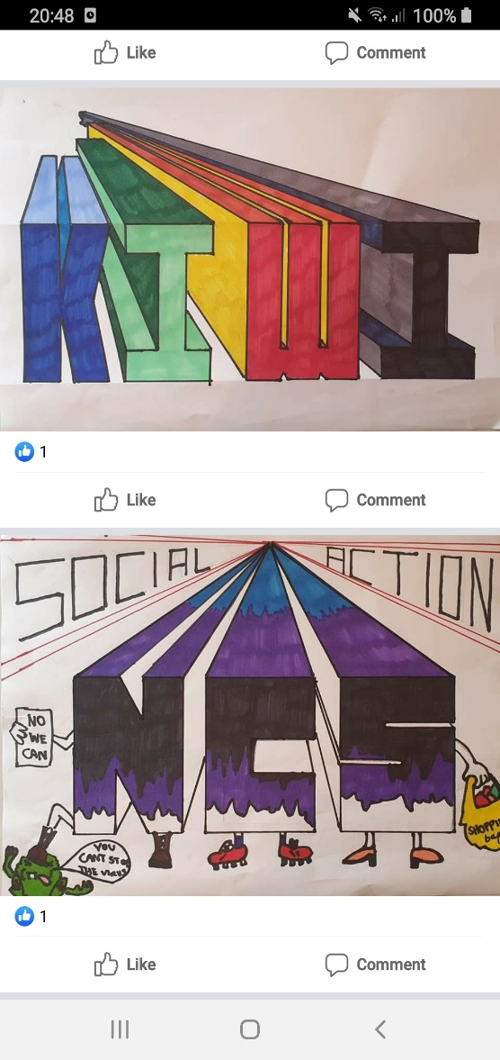
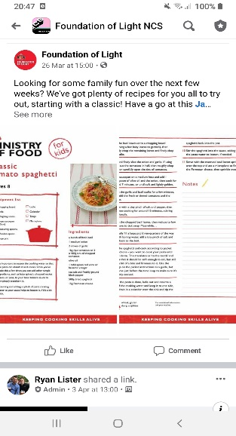
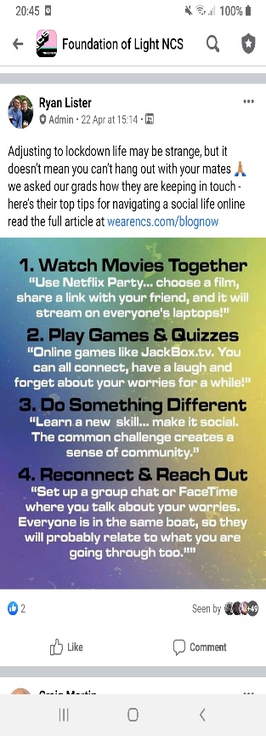
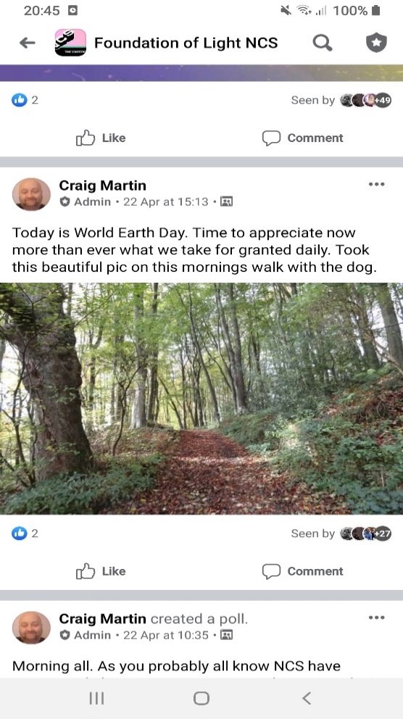
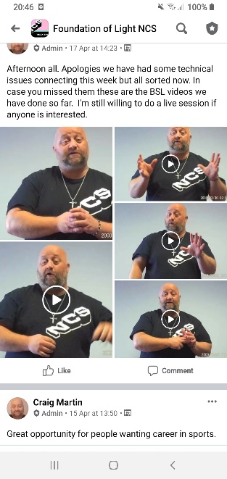
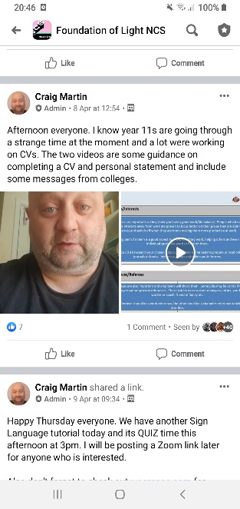
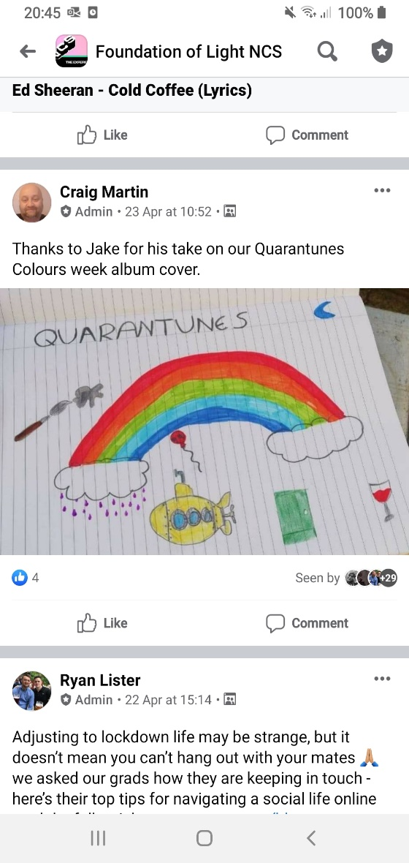
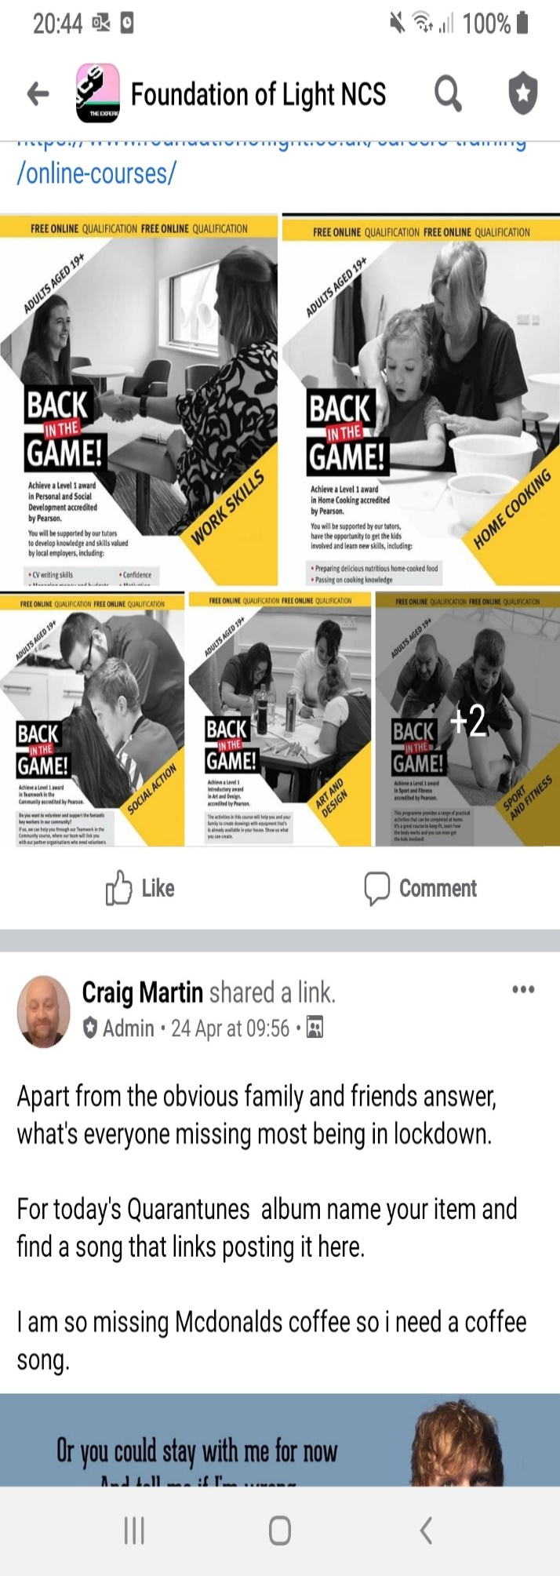
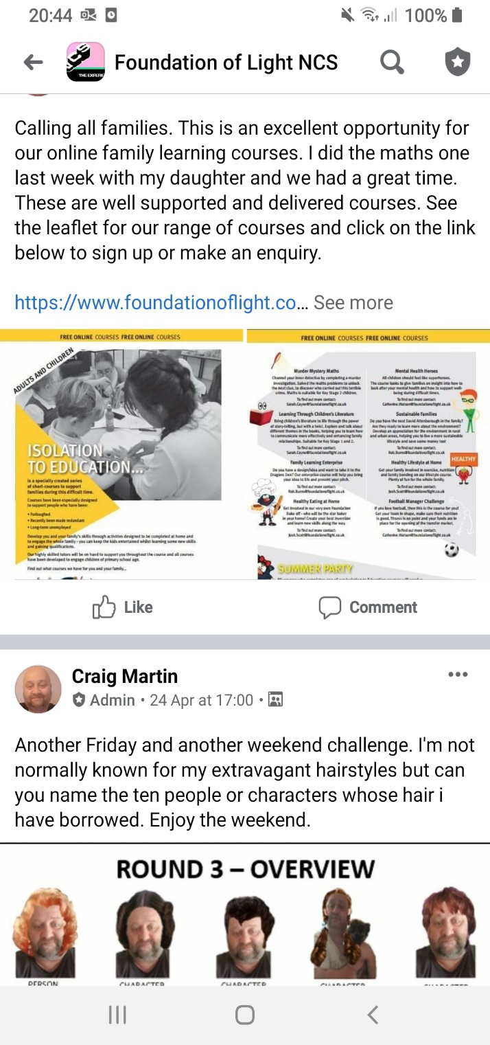
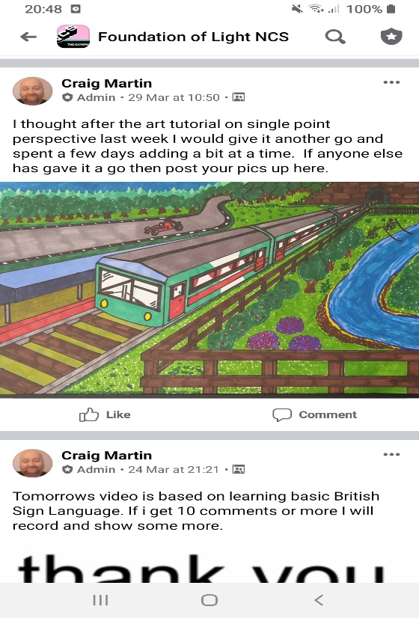

Data Protection, Safeguarding and Prevent
Foundation of Light Data Protection Statement
The Foundation of Light takes Data Protection very seriously and ensures compliance with the Data Protection Act 2018 and the General Data Protection Regulation (GDPR) 2018. All data is requested, used and stored in line with the Foundation of Light Data Protection Policy that can be found on the Foundation of Light website. Data is never shared with outside parties for sales purposes. Under the Right to be Forgotten element of GDPR, individuals can request that the Foundation of Light deletes records relating to them where the personal information held is no longer required for legitimate business need, legal or regulatory obligation or the purpose it was originally collected for. The Foundation of Light can refuse requests to delete personal data in line with the above. For example, data pertaining to a safeguarding concern, will not be deleted, even when requests for deletion have been made. You have the right to withdraw your consent or change your contact preferences at any time. For further information see https://www.foundationoflight.co.uk/privacy-cookies/ The Foundation of Light retains photographs/videos for five years. For further information see the Foundation Of Light’s Record Retention Policy
Foundation of Light Safeguarding team
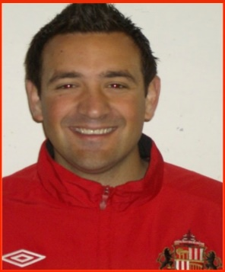
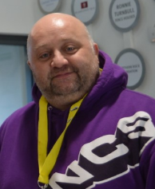
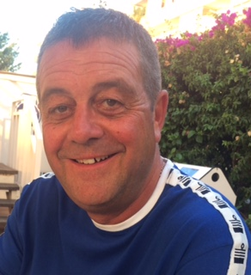

Craig Martin NCS manager and Safeguarding Champion
Tel: 07432 489 667
craig.martin@foundationoflight.co.uk

Keith Brazier Safeguarding Lead Officer
Tel: 0191- 5634757 keith.brazier@foundationoflight.co.uk

Jamie Wright – Managing Director and Safeguarding Lead Officer
Tel: 0191 563 4727
jamie.wright@foundationoflight.co.uk

Our Safeguarding team are pro-active, it is our role to keep all of our participants safe and recognise potential risks and dangers whilst on our programmes. We also have a duty to protect young people and vulnerable adults and protect someone from more harm after something has happened.
External Key Contacts
If in the unlikely event you can't get in touch with a Foundation safeguarding team member, and you are concerned about a 3rd party,
A CHILD
- Sunderland :0191 5515560
- County Durham: 03000267979
- South Tyneside: 0191 4245010(office hours) 0191- 456203 (Out of hours)
AN ADULT
- Sunderland: 0191-52055609 (Office hours) or 01915205552 (out of hours)
- County Durham: 0300267979
- South Tyneside: 0191 4244049

Information and Personal support services available
The Mix is a digital charity in the United Kingdom. Their main remit is ‘to take on the embarrassing problems’ and subjects close to the hearts of the young people who use its service, including any things from exam stress to sex. Working with anybody under the age of 25, providing them ‘essential support’ via a range of different channels, inclusive of a free helpline and chat service, articles and peer-to-peer community chats. Tel 0808- 8084994 https://www.themix.org.uk/
Addaction is a drug and alcohol service offering support for adults, young people, parents/carers and professionals; providing a free confidential specialist service specifically for young people, known as Young Addaction. Addaction runs over 120 projects around the country. The site has an online directory to enable users to search locally. Tel – 020 7251 58660 www.addaction.org.uk info@addaction.org.uk

Broken Rainbow is dedicated to supporting domestic violence and abuse within and against the Lesbian, Gay, Bi-sexual & Transgender communities. www.brokenrainbow.org.uk 0300 999 5428 or freephone 0800 999 5428

Bullying UK offers support to young people, parents and schools in all aspects of bullying including cyber-bullying, bullying in school and bullying in the workplace. The site offers an online chat facility to access advice and support, as well as email and telephone contact options. Bullying UK supports National Anti-Bullying Week. www.bullying.co.uk Helpline: 0808 800 2222 (7am – midnight) calls during the night answered by Samaritans.

NSPCC works in partnership with ChildLine to protect children across the UK through a range of services for both children and adults, including national helplines and local projects. Projects in local communities offer direct services for children who have experienced, or are at risk of, abuse. NSPCC services include helplines, report line, general enquiries and specialist advice and information for adults and professionals in order to help them protect children. www.nspcc.org.ukhelp@nspcc.org.uk Report a concern: 0808 800 5000 (open 24/7 for help, advice and support) SMS: 88858

Safecall (County Lines) provides a referral and support service for parents, professionals and young people. The service offers young people a non-judgemental, safe space to talk about their experiences in confidence – reassuring them, exploring choices, and helping formulate safety plans. The service also reaches out to the child’s parent/carer, offering access to emotional support and safety advice. Call:02083925710,email SafeCall@missingpeople.org.uk, website: www.missingpeople.org.uk/safecall marketing materials: Partners@missingpeople.org.uk

Thinkuknow - A CEOP site to support children, young people, parents and carers, and teachers with advice relating to safe use of the internet and mobile technology. Thinkuknow provides a report button to use when someone may feel uncomfortable or worried about someone they are chatting to online. www.thinkuknow.co.uk

How to sign up?

Thank you for your interest in coming away with the Foundation of Light on our NCS Summer 2021 programme. If you need more information before you make a final decision than please email on craig.martin@foundationoflight.co.uk or ryan.lister@foundationoflight.co.uk, ring the team on 07432 489 667 or join the Foundation of Lights NCS Instagram and Facebook pages.
Download the sign up forms, or complete the ones in the pack – Expression of Interest, Foundation of Light consent form and NCS Medical form.
STEP 1

Hand completed forms back to school and we can arrange to collect from there or photograph or scan and return to craig.martin@foundationoflight.co.uk
STEP 2

All forms are checked and the data is entered onto the NCS national database Salesforce.
STEP 3

STEP 4
Once complete on the system NCS staff will be in touch for the next step.

Make a payment to secure the place. This is normally done with card over the phone or online. You will be emailed a receipt along with a confirmation of the place being secured.
STEP 5

Join the Facebook group Foundation of Light NCS Sign ups for information, updates, keep warm events and announcements.
STEP 6



Please print clearly in blue or black ink or type and return.
Young person details
First name |  |  |  |  |  |  | Last name
Mobile number |  |  |  |  |  |  | Date of Birth
Gender |  |  |  |  |  |  | Postcode
Address
Email address
School |  |  |  |  |  |  | Year group
This section is about your parents/guardians or carers
First name of contact |  |  |  |  |  |  | Last name of contact
Mobile number |  |  |  |  | Email
Relationship to young person |  |  |  |  |  |  | The parent/guardian or carer must be over the age of 18.
Please state the payment method you would like to use to secure the place by placing an X in the relevant box
Card |  |  |  | Cash |  |  |  | Cheque
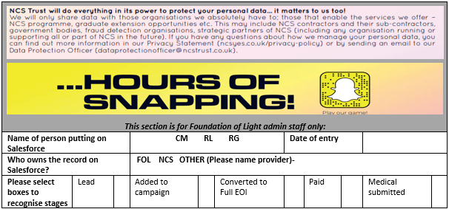
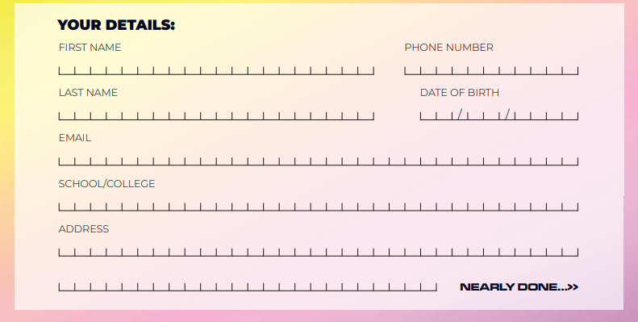
FOUNDATION OF LIGHT - PERSONAL INFORMATION AND CONSENT FORM
Please complete this form and return it to your course tutor/coach before taking part. Please see Appendix 1 or https://www.foundationoflight.co.uk/privacy-cookies/ for our Data Protection Statement.
Activity/course |  |  |  |  | NCS Summer 2021 |  |  |  | Activity dates |  | June to August 2021
Venues |  |  |  |  | Beacon of Light |  |  |  | University of Sunderland |  |  |  |  |  |  |  | Outdoor activity centre
Please note that any consent given on this form, relates only to the activity/course stated above.
Section A: Participant’s Personal Information Please note that only individuals with parental responsibility can give consent on behalf of their child. If you are completing this form on behalf of your child, please place a cross in the box to the right:
Participants name |  |  |  |  |  |  |  |  |  |  |  |  |  |  | Date of Birth
Full address including postcode
Daytime telephone number |  |  |  |  |  |  |  |  |  |  | Evening telephone number
Parents carers name if participant is under 18
Parents/carers email
Emergency Contacts: Please provide an alternative contact in case of emergency:
Name of contact |  |  |  |  |  |  |  |  |  |  |  | Contact Number
Name of contact |  |  |  |  |  |  |  |  |  |  |  | Contact Number
Section B: Photography/Video Consent/Digital Voice Recording The Foundation of Light may sometimes take photographs/videos/digital voice recordings. Do you consent to images or recordings of the participant named above to be used for these purposes? |  |  |  |  |  |  |  |  |  |  |  |  |  |  |  |  |  |  |  |  | I consent |  | I do not consent
Social Media (Facebook, Instagram, Twitter, LinkedIn, YouTube)
Media (Foundation of Light Website, Newspapers, Radio, Podcasts, Television)
Publicity and Corporate (Leaflets, Flyers, Posters, Reports, Presentations)
Section C: Contact Preferences The Foundation of Light, The Beacon of Light would like to contact you occasionally about products and services we think you will find interesting. If you would like to hear from us, please place a cross in the boxes below:
Post |  |  | Phone |  |  |  |  | Email |  |  |  |  | SMS |  |  |  |  | No contact
Section D: Additional Information. Is there any other information that the Foundation of Light need to be made aware of in order to maintain safeguarding and/or health and safety standards? This may include unspent criminal convictions, substance misuse, or other aspect not mentioned in this form:
Yes |  |  |  | No |  |  | If Yes, an appropriate member of staff will contact you to discuss the details

NCS Medical Form – Guardian
Step 1: Personal Details

Please read the following details before completing the form and retain a copy for future reference.

Name of Young Person | Name of person completing the form | Relationship to YP
This form should be completed by a responsible adult over the age of 18, preferably the legal guardian. This form is best completed by the parent/guardian together with the young person who will be participating in the NCS programme. The purpose of this form is to gather the information needed to keep your young person safe and support their participation during NCS programmes. Please provide as much detailed information as possible. The information you provide will be shared with the programme providers, as part of the necessary administration of the NCS programme. All information is handled and stored in line with the Privacy Policy

As explained above and in the Privacy notice, we are relying on your explicit consent to process the information given in response to the questions in this form. You provide this consent when you tick the box at the end of this statement. You have the right to withdraw this consent at any time, but this will not affect the lawfulness of any processing activity we have carried out prior to you withdrawing your consent. However, where we also rely on another basis for processing the information about your young person, you may not be able to prevent the processing of your data. (For example, if the information is necessary to organise the Programme for which you are applying.)

If there is an issue with the processing of the information, please contact our Data Protection Officer via dataprotectionofficer@ncstrust.org.uk Your Rights Under the GDPR. You have a number of rights that you can exercise in certain circumstances. These are free of charge. In summary, you may have the right to:
- Ask for access to the personal information about your young person and other supplementary information;
- Ask for correction of mistakes in the data about your young person or to complete missing information we hold on the young person;
- Ask for the personal information about the young person to be erased, in certain circumstances;
- Receive a copy of the personal information you have provided to us or have this information sent to a third party. This will be provided to you or the third party in a structured, commonly used and machine-readable format, e.g. a Word file;
- Object at any time to processing of the personal information about the young person for direct marketing;
- Object in certain other situations to the continued processing of the personal information about the young person;
- Restrict our processing of the personal information provided in certain circumstances. If you want more information about your rights under the GDPR please see the Guidance from the Information Commissioner's Office on Individual’s rights under the GDPR.

If you want to exercise any of these rights, please:
- Use the contact details at the end of this form;
- We may need to ask you to provide other information so that you can be identified;
- Please provide a contact address so that you can be contacted to request further information to verify your identity;
- Provide proof of your identity and address;
- State the right or rights that you wish to exercise. We will respond to you within one month from when we receive your request.

NCS Trust Data Protection Officer can be contacted via dataprotectionoffier@ncstrust.org.uk

Please confirm that your young person is aware you are providing this information on their behalf to NCS, that you have informed them that it will also be shared with the programme providers and have told them of their rights in relation to such data and under GDPR, as listed below. You are also confirming either that they have given you authority to pass on this data to NCS or, where you feel they may not fully understand the implications behind providing this data and their rights in relation to it, as the party with legal responsibility for them, you are giving that consent on their behalf, to the extent necessary. Your young person will be asked separately, where possible, to confirm such consent directly to NCS.

Please write name or sign to state you confirm to the statement above:
Please place a cross in the respective boxes to give your consent for the information provided on this form to be used as outlined. Without your consent for the use of the information for programme participation, it may not be possible for your young person to be accepted on the NCS programme

For programme participation |  |  |  | For monitoring |  |  |  |  |  | For Research purposes
Are you the young person’s legal guardian?
Please give the details of two emergency contacts.
Emergency contact name |  |  | Contact number |  |  |  |  |  |  | Relationship to YP
Emergency contact name |  |  | Contact number |  |  |  |  |  |  | Relationship to YP
About the Young Person
Is English their first language |  |  |  |  |  | If no, please state their first language
If no, do they need support to understand spoken or written English? |  |  |  |  |  | Please state the Young Person’s Ethnicity
Has the Y/P had free school meals in the last 8 years? |  |  |  |  |  | Do they have an educational health care plan?
Please state gender of young person |  |  |  |  |  | Is the young person in care of the local authority?
Does the young person have any dietary requirements, include allergies, intolerances or choices?
If answered
YES
please give details

Does the young person have any allergies other than food allergies?
If answered
YES
please give details

Does the young person have any special educational needs or disabilities that are diagnosed or currently going through a diagnosis process?
If answered
YES
please give details

Does the young person have any mental health issues that are diagnosed or currently going through a diagnosis process?
If answered YES
please give details of issues and involvement with CAHMS or CYPS
About the Young Person – safety on programme
Does the young person have any pre-existing medical conditions?
If answered
YES
please give details
Does the young person take any medications?
If answered YES
please give details of medication, why it is taken and the frequency.
Has the young person required a hospital stay in the last two years? ,
If answered YES
please give details if treatments and appointments are ongoing.
Does the young person wear glasses or contact lenses? |  |  |  |  | If yes is the difficulty with reading, seeing long distance or both?
Does the young person have any hearing difficulties? |  |  |  | Give details if the answer was YES
Is the young person fully up to date with vaccinations? |  |  |  | Is The YP pregnant? |  |  |  |  |  |  | Can they swim?
Support on programme
Phase 1 is an outdoor activity centre more than 90 minutes away from home. Give details of any support they may need on programme. This can include requests to share with a friend or someone from school.

Phase 2 is living at Sunderland University for a week in flats, young people will be involved in budgeting, cooking and career workshops. Give details of any support they may need on programme.

Phase 3 involves the planning, delivery and evaluation of social action projects. Give details of any support they may need on programme.

Does the YP have any caring responsibilities?
Does the Y/P have any involvement with Youth Offending, pending convictions, current court process, or are subject to a curfew or electronic tag?

Please inform us in the space below if you feel there is anything else that we need to know to support your child on the programme.

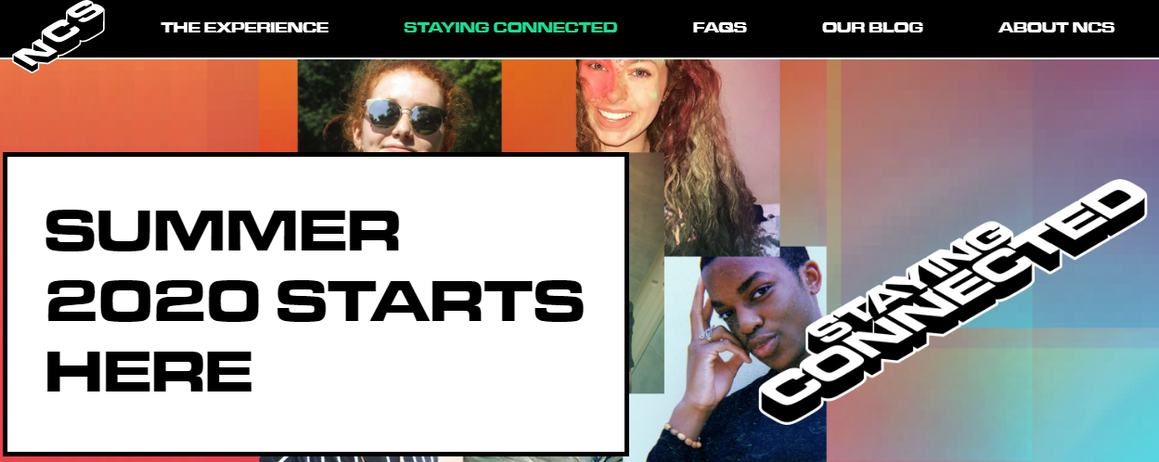
SUMMER 2021
STARTS HERE

