Southmoor Academy School Uniform
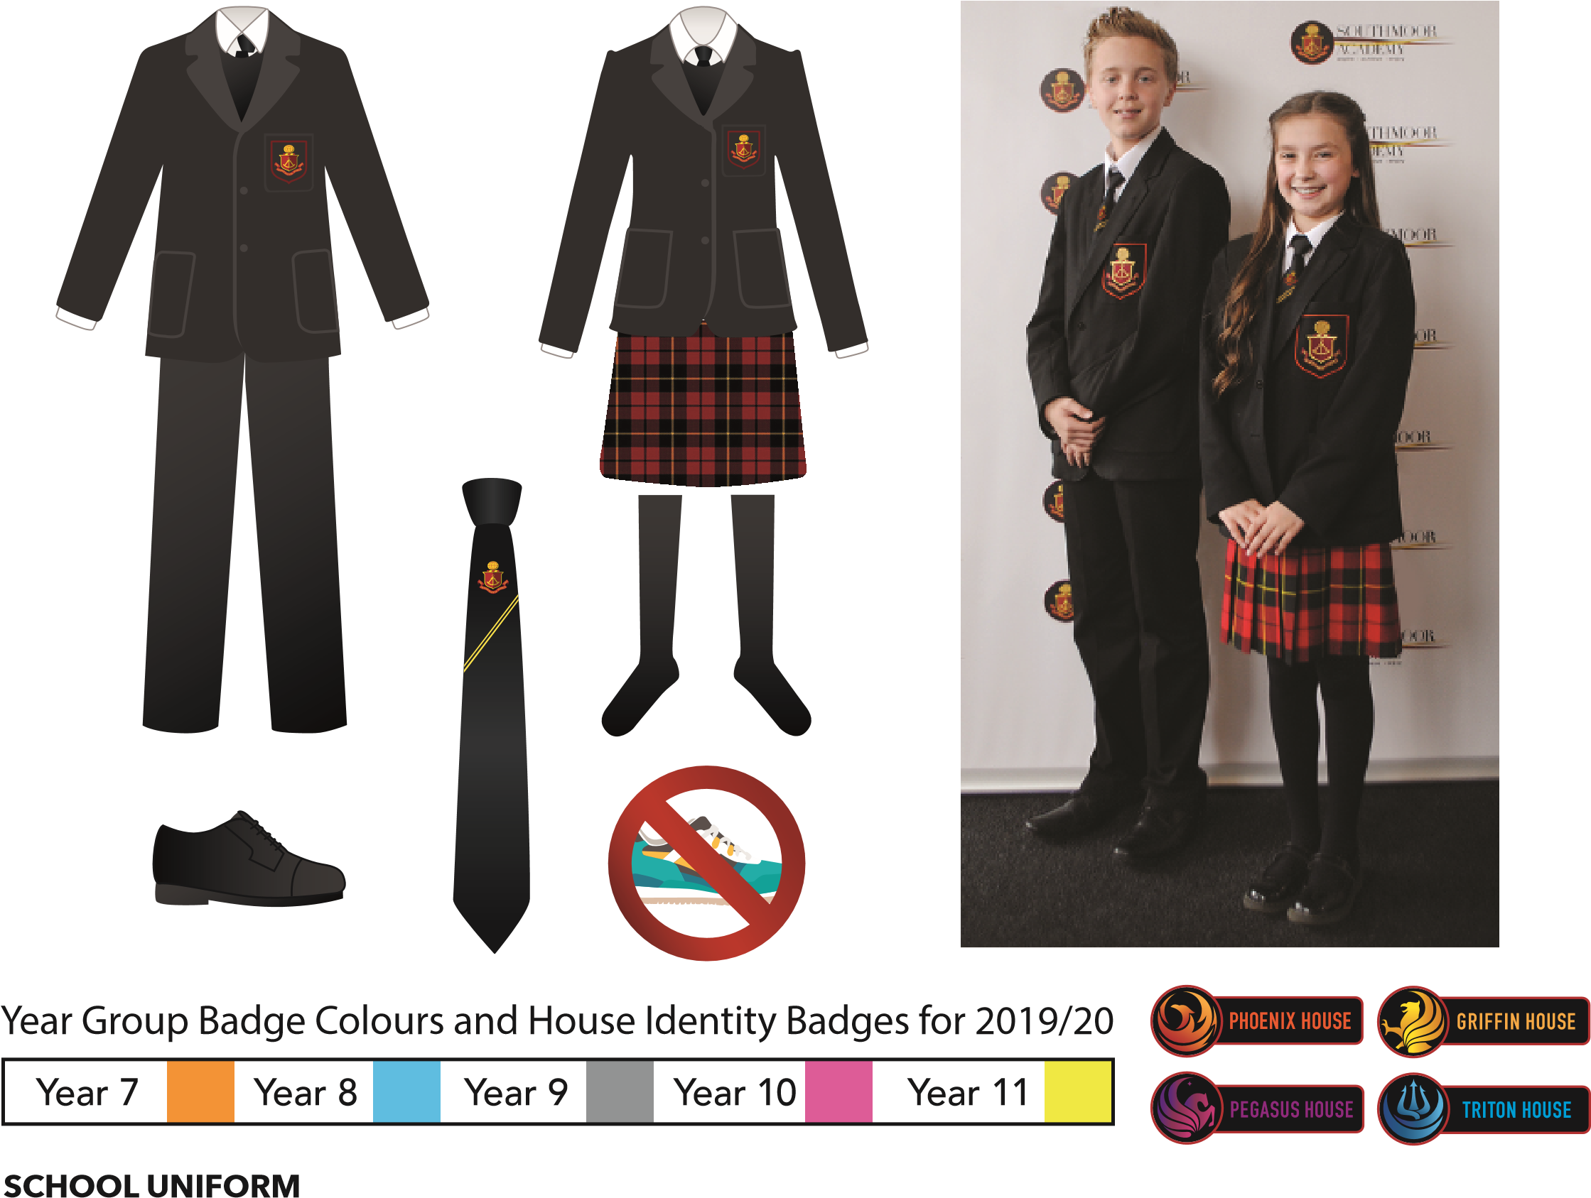
for 2020/21

School Uniform

- Black blazer with Southmoor year group identity trimmed badge* Blazers must not be carried in bags
- House metal badge (provided by the school in September)
- Plain, logo free, white shirt with collar – tucked into trousers or skirt
- Plain black trousers (corduroy, flared, denim, canvas or ‘skinny’ fashion trousers are not allowed) or
Red tartan skirt (Southmoor branded)* No other skirt can be worn
- School tie to be worn at all times*
- Black v-neck, long sleeved jumper, tank top or cardigan all with Southmoor badge only (optional)*
- Plain black, grey or white socks or plain black tights should be worn
- Smart black shoes only (no trainers, plimsolls, boots or brand logos)
- Hair decorations are not allowed. Hijabs, if worn need to blend in with the school uniform
- A suitable bag MUST BE brought to school for all school sessions.
- Jewellery (except a watch), excessive make-up, fake tan and nail varnish/gel nails are not permitted in school for health & safety reasons. Piercings are not allowed
- A suitable smart coat may be worn over the blazer in cold weather. Please note that sports jackets, denim jackets and hoodies are not permitted. Coats must be removed when in class

CASUAL, HOODED AND OUTDOOR TOPS MUST NOT BE WORN UNDER BLAZERS
Only Academy authorised badges and wristbands may be worn.
Graffiti on uniform is strictly forbidden. Extreme hair colouring, cuts and styles are not permitted.
All items of uniform should be marked with the pupil’s name and form

All items marked with * are specific items that MUST be purchased our official school uniform supplier.

Southmoor Academy PE Kit
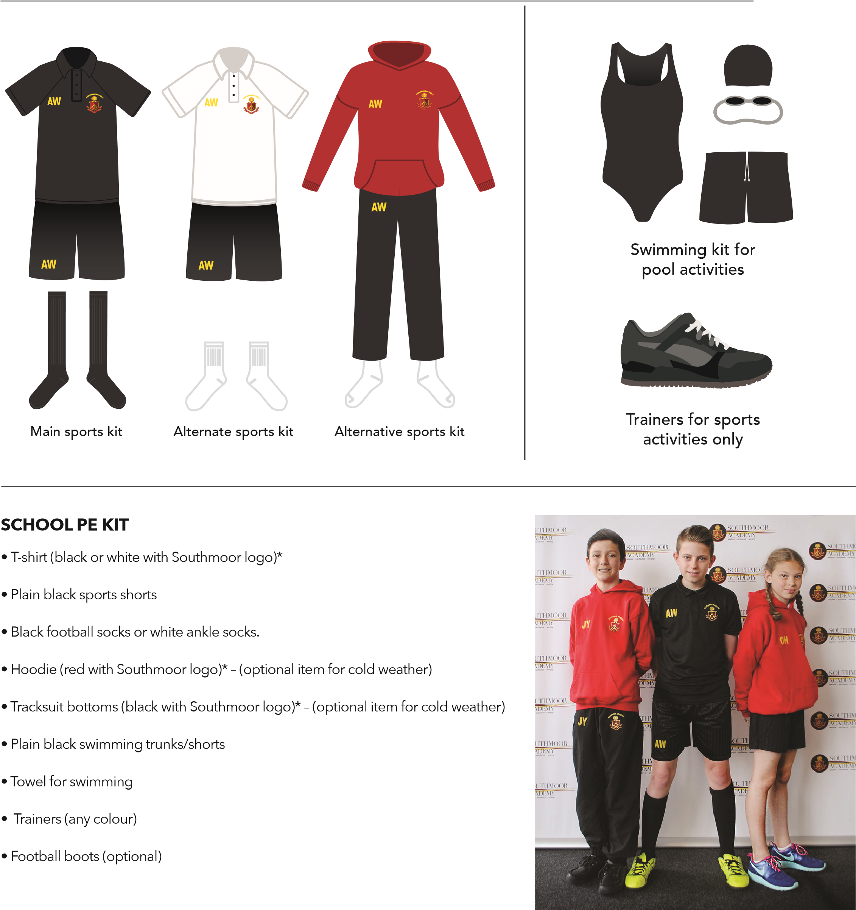• Swimming Cap (any colour) required for pupils with long hair
Please ensure all items of PE kit are clearly marked with the pupil’s name and form.
There are over 1000 pupils in our school and items can be easily lost or misplaced! Alternatively, our PE Kit supplier can print your child’s initials on their PE kit for a small charge. NB: Cycling shorts and leggings are not part of the PE kit.
All items marked with * MUST be branded kit with school logo, which only can be purchased from school supplier, Aceworkwear, 13a Blind Lane, Silksworth, Sunderland, SR3 1AT, Tel: 0191 5800456, Website: aceworkwear.co.uk. Size guides can be found on the company website.

