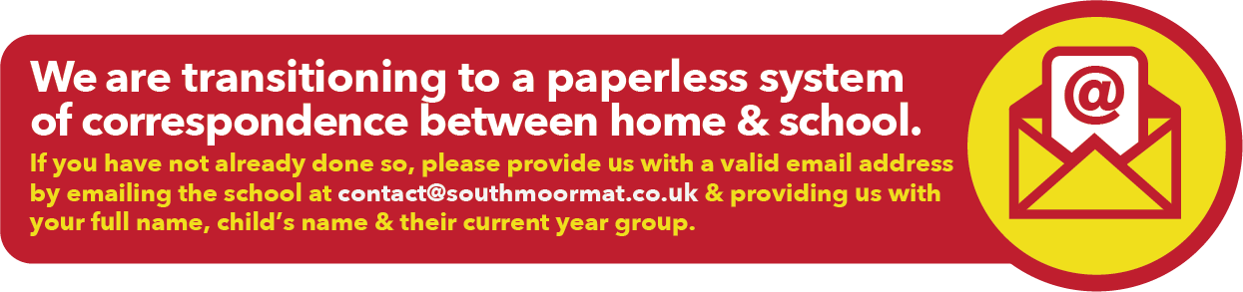

13th July 2018

End of Summer Term Arrangements

Dear Parent/Carer

The last day of the Summer Term is Friday 20th July. Please note that school will end and pupils will be dismissed at 12.00pm, as opposed to the usual end of school day time of 3.05pm on this day. Meals will be made available in the School Restaurant for pupils eligible for free school meals only at 12.00pm.

Pupils return to school for the start of the new academic year on Wednesday 5th September at 8.30am.

We wish all of our pupils a safe and happy summer holiday.

Yours sincerely

Mrs L Mellefont
Assistant Principal (Personal Development Behaviour & Welfare)

